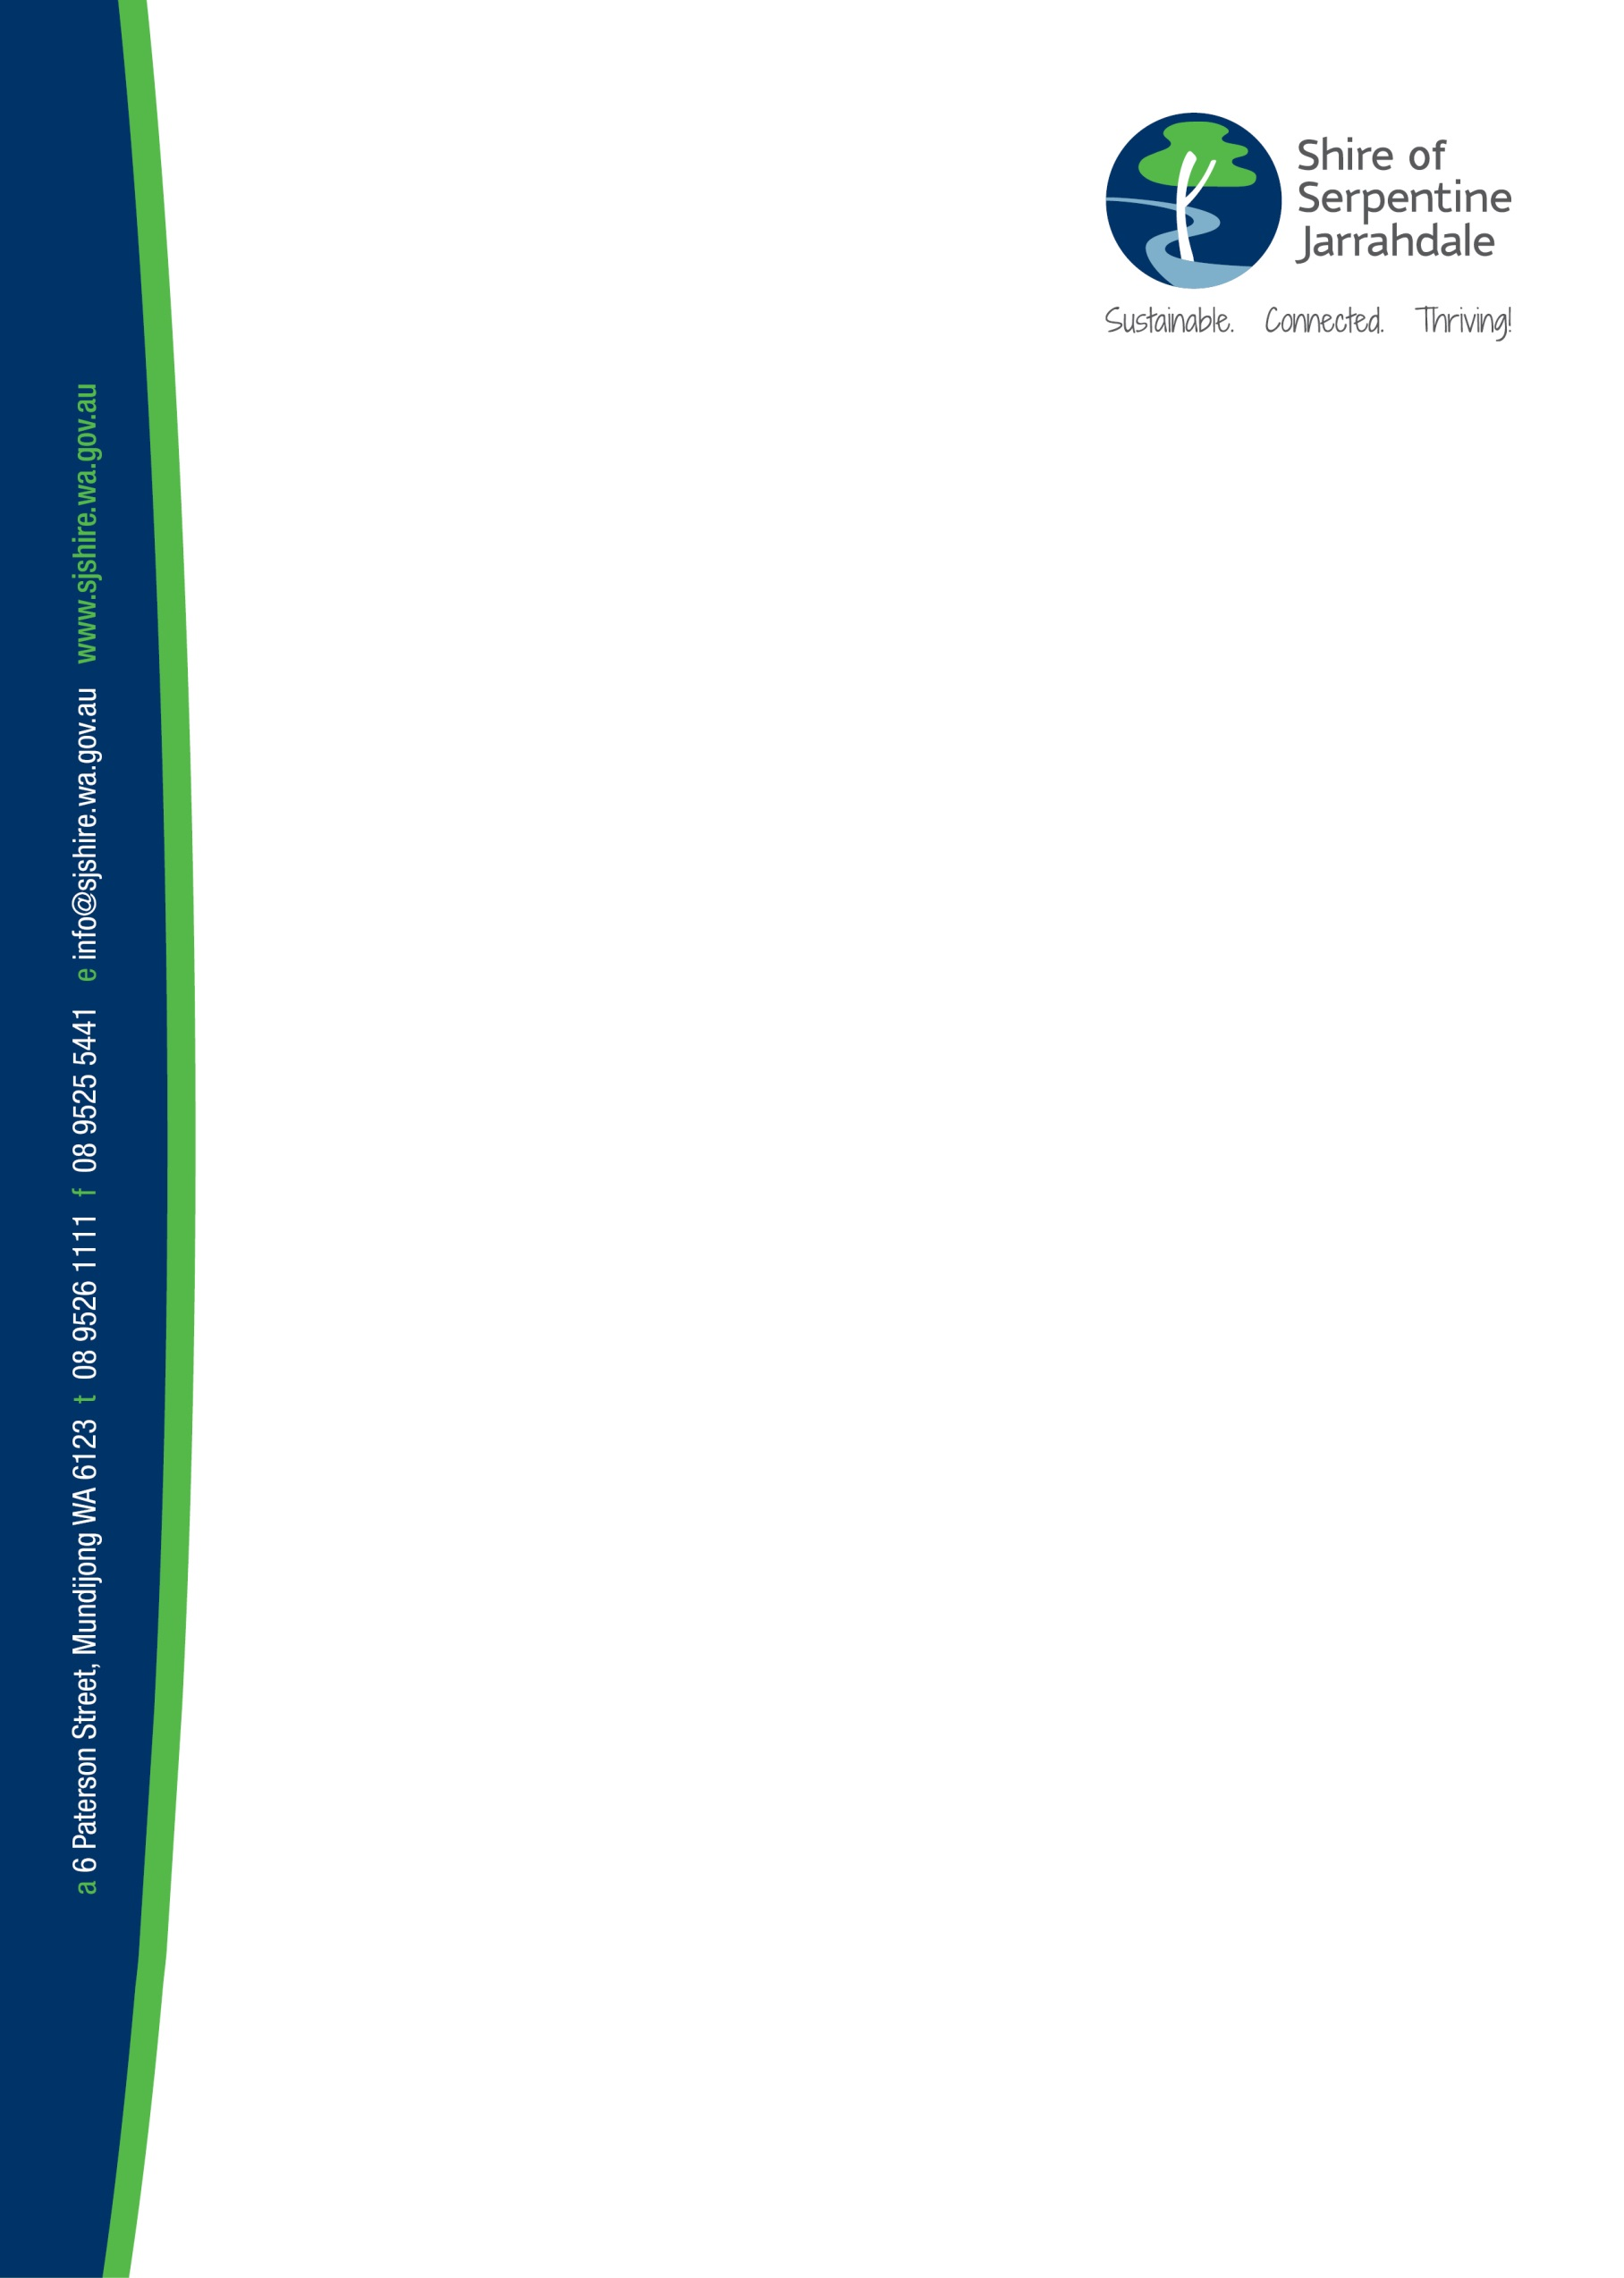

Shire of Serpentine Jarrahdale
Youth Services Registration Form
This membership form will enable you to participate in all Shire of Serpentine Jarrahdale Youth Services programs and events. Memberships are for young people up to the age of 18 years old and are valid until you turn 18 years of age.
If any of your or your child’s information changes please send us an email at youth@sjshire.wa.gov.au.
For further information please contact 9526 1111.

Registration Form
Personal Information (to be completed by Parent/Guardian for under 18)
1. Participant Details

First Name: ________________________ Last Name: ________________________

Date of Birth: _______________________ Age: _________ Gender: _______________

Name of School: ______________________________________ Year Level: _______

Street Address: _______________________________________________________
Suburb: ______________________ State: __________ Post Code: ______________

Email: ________________________________________________________________
Would you like to join our email list to receive information about future term/school holiday programs and events? ☐Yes ☐No

2.Parent/Guardian Details (if under 18)
Parent/Guardian Name: ________________________________________________

Relationship to Young Person:
☐ Mother ☐ Father ☐ Other, specify: ________________________________

Street Address (if different from above): _________________________________________________________________
Suburb: ______________________ State: __________ Post Code: ______________

Home phone: ______________________ Mobile phone: ______________________

Email: ________________________________________________________________
Would you like to join our email list to receive information about future term/school holiday programs and events? ☐Yes ☐No

3. Additional Emergency Contact Details

In the case of an emergency we will always try and call the parent/guardian contact first, however, if they are uncontactable this emergency contact will be used.

Emergency Contact Name: _____________________________________________
Phone Number: _______________________________________________________
Relationship to Young Person:
☐ Mother ☐ Father ☐ Other, specify: ________________________________

4. Medical/Emergency Details
Please provide details
Food or other Allergies No ☐ Yes ☐________________________________
Medication (if appropriate) No ☐ Yes ☐________________________________
Dietary requirements No ☐ Yes ☐________________________________
Medical condition No ☐ Yes ☐________________________________
Other: _______________________________________________________
_____________________________________________________________

5. Photography Consent

I give permission for the Shire of Serpentine Jarrahdale to use my child's photograph for promotional purposes. I am aware that this photo may be used in media, print, social media and electronic advertising, including cinema advertising and any other forms of advertising at the Shire’s discretion. I agree that I will not seek from the Shire of Serpentine Jarrahdale any talent fees or compensation for using the photograph.
Do you give photography consent for your child if under 18 or yourself if you are over 18?
Yes ☐ No ☐
6. Attendance Conditions Consent
As the parent/guardian of _________________________________________ I consent to their participating in this program. Although I realise every care will be taken:
• I give consent to staff to take whatever action deemed necessary to ensure the safety and wellbeing of this participant.
• I authorise staff to obtain medical assistance that they deem necessary and agree all medical expenses including ambulance transportation for this participant is the responsibility of the parent/guardian.
• I release the Shire of Serpentine Jarrahdale, its staff and contractors and indemnify all against any accidents to the participant and loss and damage to personal property when taking part in Shire of Serpentine Jarrahdale Youth Services programs and events.
• I agree to the Shire of Serpentine Jarrahdale Youth Service’s behavioural conditions and relevant policies. These can be found on our website at the following www.sjshire.wa.gov.au/what-we-do/community-and-recreation/youth-development-services-2/ or can be provided upon request.

7. Signature Declaration

I, ______________________________ hereby give permission for_____________________________ to attend events organised by the Shire of Serpentine Jarrahdale Youth Development team.
Signed: ______________________ Date: ______________________

