Significant Tree Register
Assessment Reports – Shire Trees

Contents
Significant Tree Register – Assessment Report – ST 03 3
Significant Tree Register – Assessment Report – ST 04 4
Significant Tree Register – Assessment Report – ST 05 6
Significant Tree Register – Assessment Report – ST 07 7
Significant Tree Register – Assessment Report – ST 08 8
Significant Tree Register – Assessment Report – ST 10 9
Significant Tree Register – Assessment Report – ST 21 10
Significant Tree Register – Assessment Report – ST 27 11
Significant Tree Register – Assessment Report – ST 31 12
Significant Tree Register – Assessment Report – ST 32 13
Significant Tree Register – Assessment Report – ST 34 17
Significant Tree Register – Assessment Report – ST 36 18
Significant Tree Register – Assessment Report – ST 37 19
Significant Tree Register – Assessment Report – ST 38-39 20
Significant Tree Register – Assessment Report – ST 41 21
Significant Tree Register – Assessment Report – ST 42 22
Significant Tree Register – Assessment Report – ST 43 23
Significant Tree Register – Assessment Report – ST 44 24
Significant Tree Register – Assessment Report – ST 46 25
Significant Tree Register – Assessment Report – ST 63 26
Significant Tree Register – Assessment Report – ST 66 27
Significant Tree Register – Assessment Report – ST 68 28
Significant Tree Register – Assessment Report – ST 71 29
Significant Tree Register – Assessment Report – ST 72 30
Significant Tree Register – Assessment Report – ST 73 31
Significant Tree Register – Assessment Report – ST 74 32
Significant Tree Register – Assessment Report – ST 75 33
Significant Tree Register – Assessment Report – ST 76 34
Significant Tree Register – Assessment Report – ST 77 35
Significant Tree Register – Assessment Report – ST 78 36
Significant Tree Register – Assessment Report – ST 79 37
Significant Tree Register – Assessment Report – ST 85 38
Significant Tree Register – Assessment Report – ST 87 39
Significant Tree Register – Assessment Report – ST 88 40
Significant Tree Register – Assessment Report – ST 91 41
Significant Tree Register – Assessment Report – ST 92 42
Significant Tree Register – Assessment Report – ST 93 43
Significant Tree Register – Assessment Report – ST 94 44
Significant Tree Register – Assessment Report – ST 95 45
Significant Tree Register – Assessment Report – ST 96 46
Significant Tree Register – Assessment Report – ST 98 47
Significant Tree Register – Assessment Report – ST 99 48
Significant Tree Register – Assessment Report – ST 100 49
Significant Tree Register – Assessment Report – ST 101 50
Significant Tree Register – Assessment Report – ST 102 51
Significant Tree Register – Assessment Report – ST 103 52

Significant Tree Register – Assessment Report – ST 03

Registry number: ST 03
Species: Corymbia calophylla (marri)
Number of trees: Six

Height: 12 m, 12 m, 6 m, 3 m, 12 m, 8 m
DBH (trunk diameter at 120cm): 33.5 cm and 27 cm (two trunks), 31 cm, 14.5 cm, 5.5 cm, 61 cm, 22.5 cm
Canopy diameter: 6 m, 6 m, 3 m, 1 m, 8 m, 4 m
Estimated age: 149, 79, 40, 19, 150, 59 years (calculated)

Address: 703 (L815) Jarrahdale Road, Jarrahdale
Location description: General Store carpark, close to Jarrahdale Road
GPS coordinates: Trees 1 to 4:
32.3367223 S, 116.0652155 E
Trees 5 to 6:
32.3367789 S, 116.0651645 E

Landowner: Crown land, Shire vested
Category of significance: 2 (size), 3 (age), 6 (location), 10 (group)
Reasons for inclusion: Large, old trees in natural groupings with habitat value. Significant to townsite and customers/tourists, providing shade, amenity and sense of place.
Risk assessment: All are suffering extensive soil compaction from vehicles parking under them, trees 5 and 6 have exposed roots, which jeopardises their health and long-term survival.
Recommendation: Include on Register because:
- Large, old trees in natural groupings with habitat value
- Significant feature of townsite, providing shade, amenity and sense of place

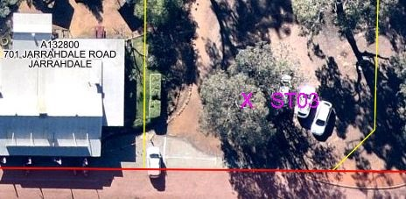

Trees 1 to 6:
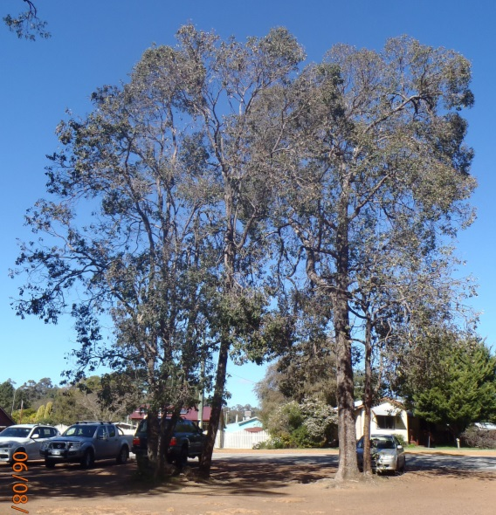
Trees 1 to 4:
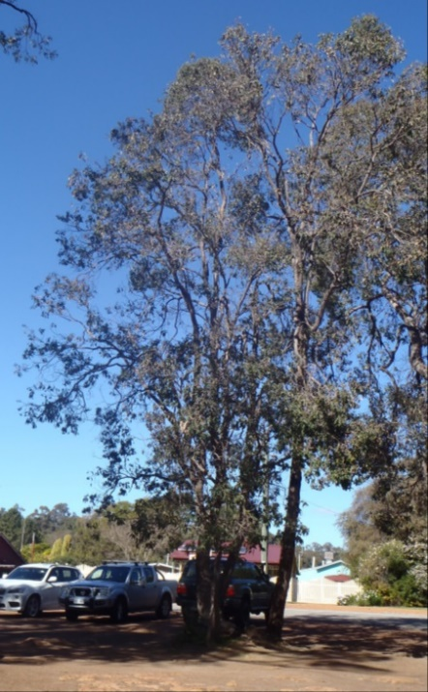
Trees 5 to 6:
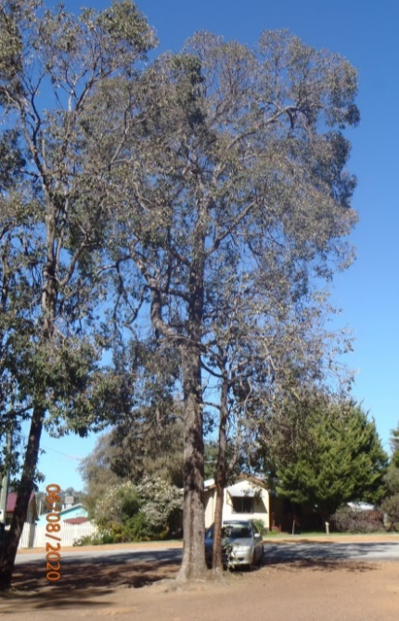

Significant Tree Register – Assessment Report – ST 04

Registry number: ST 04
Species: Eucalyptus marginata (jarrah) (trees 1, 2, 4)
Corymbia calophylla (marri) (trees 3, 5-7)
Number of trees: 7

Height: 20 m, 20 m, 18 m, 20 m, 12 m, 5 m, 8 m
DBH (trunk diameter at 120cm): 104 cm, 108 cm, 56 cm, 83 cm, 44.5 cm, 14.5 cm, 22.5 cm
Canopy diameter: 15 m, 18 m, 6 m, 8 m, 8 m, 2 m, 3m
Estimated age: 250, 260, 138, 201, 111, 41, 59 years (calculated)

Address: 703 (L815) Jarrahdale Road, Jarrahdale
Location description: General Store carpark; includes large jarrahs at south and centre of carpark
GPS coordinates: Tree 1:
32.3364991 S, 116.0654180 E
Tree 2: 32.3366237 S, 116.0653308 E
Tree 3: 32.3366668 S, 116.0654931 E
Tree 4: 32.3367427 S, 116.0654756 E
Trees 5-7: 32.3367869 S, 116.0654716 E

Landowner: Crown land, Shire vesting
Category of significance: 2 (size), 3 (age), 6 (location), 10 (group)
Reasons for inclusion: Large, old trees in natural groupings with habitat value. Significant to townsite and customers/tourists, providing shade, amenity and sense of place.
Risk assessment: Extensive soil compaction from vehicles parking under them, some exposed roots. Crown decline. Some termite activity in tree 1. Trees 4 to 7 are surrounded by native sedges and other species, and a rock circle.
Recommendation: Include on Register because:
- Large, old trees in natural groupings with habitat value
- Significant feature of townsite, providing shade, amenity and sense of place

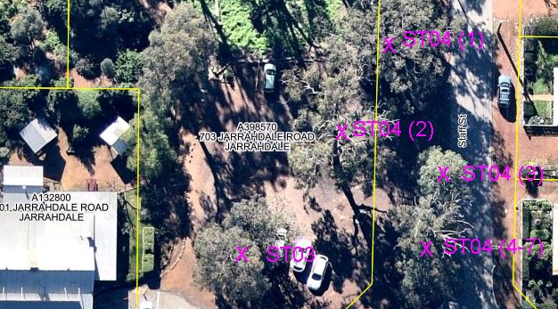

Tree 1:
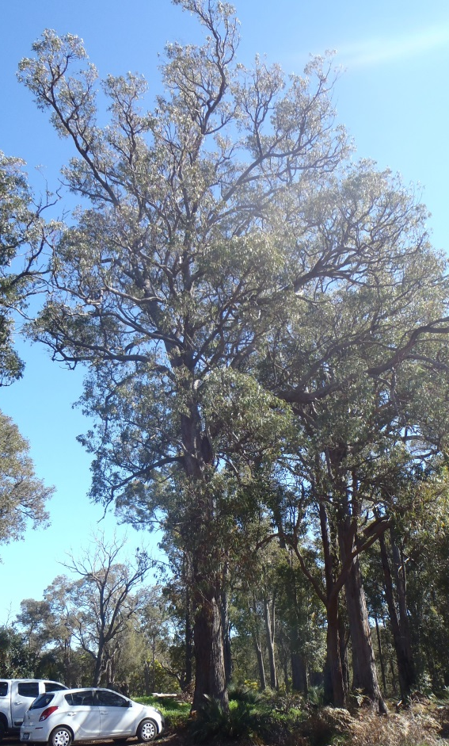

Tree 2:
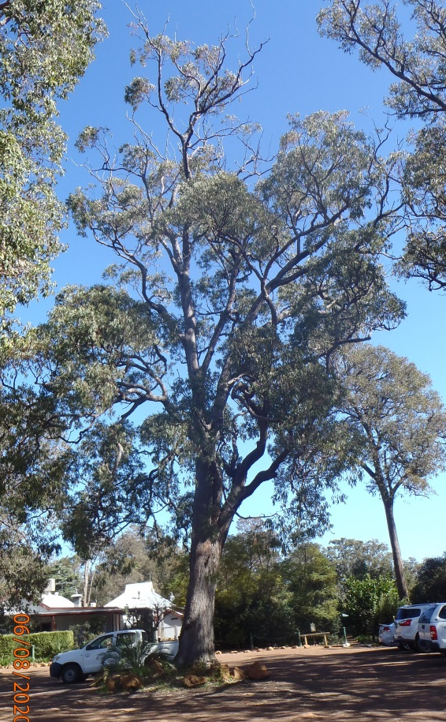

Tree 3:
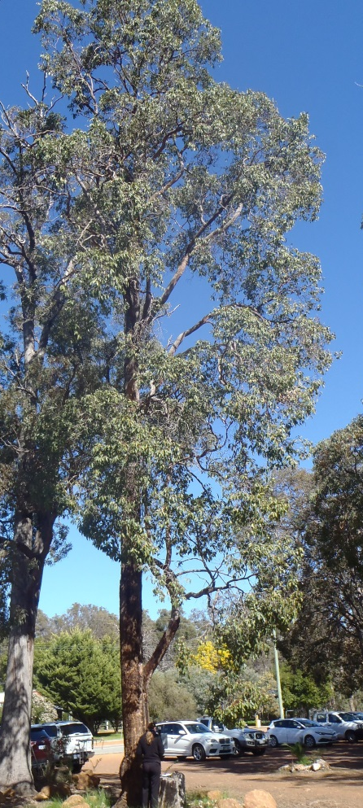

Trees 4 to 7:
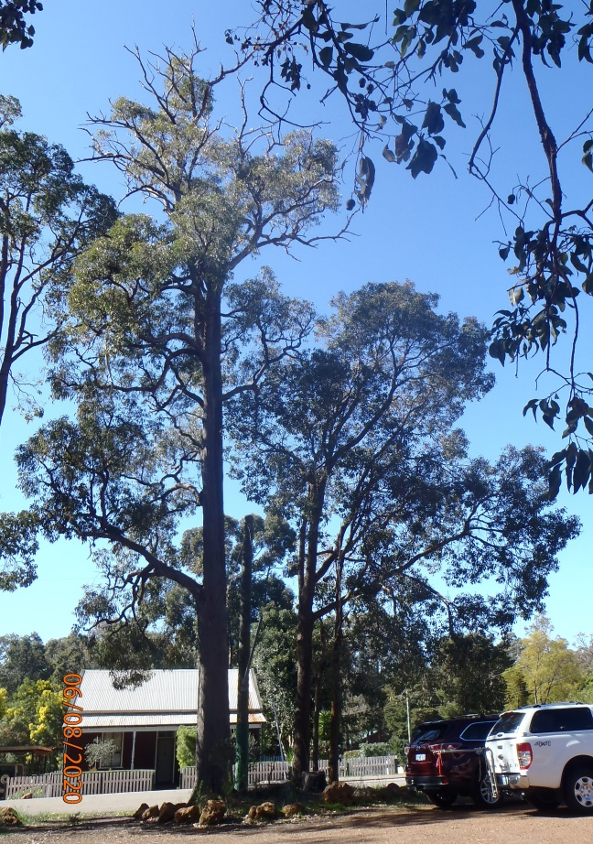

Significant Tree Register – Assessment Report – ST 05

Registry number: ST 05
Species: Eucalyptus marginata (jarrah)
Number of trees: One

Height: 15 m
DBH (trunk diameter at 120cm): 225.5 cm
Canopy diameter: 12 m
Estimated age: 535 years (calculated)

Address: Road reserve, Karnup Road, Serpentine
Location description: 120m east of Kiely Lane, on the north side of Karnup Road
GPS coordinates: 32.3661340 S, 115.8721461 E

Landowner: Crown land, Shire vesting
Category of significance: 2 (size), 3 (age)
Reasons for inclusion: King jarrah, over-mature, very significant age and size, probably one of the oldest trees in the Shire
Risk assessment: Has arboricultural report. Road upgrade and widening. Old termite activity in large scar, may need treatment or threaten stability.
Recommendation: Include on Register because:
- Very large, old tree with habitat hollows
- One of the oldest trees in the Shire

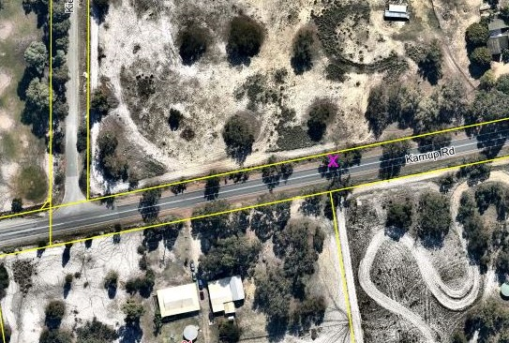

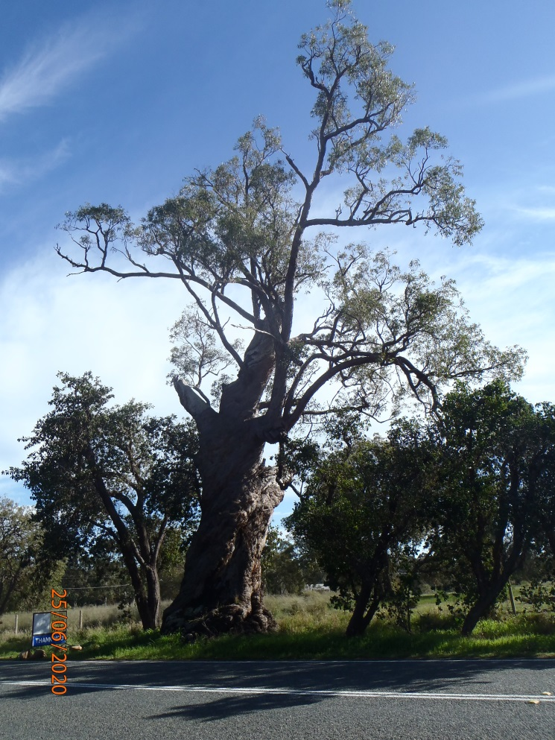
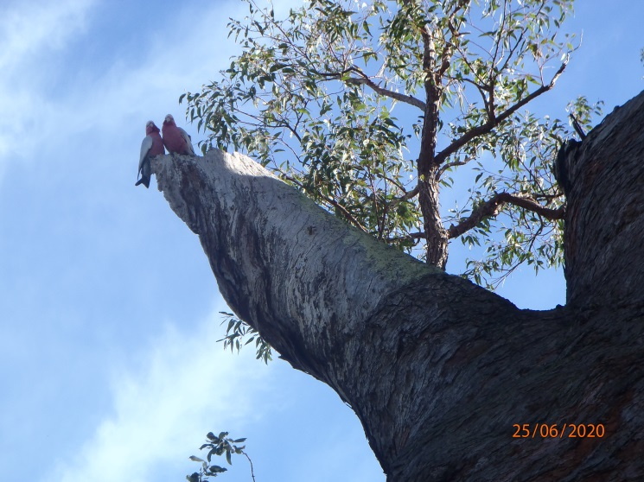

Significant Tree Register – Assessment Report – ST 07

Registry number: ST 07
Species: Casuarina obesa (swamp sheoak)
Number of trees: Approx. 440 (175 south of road, 265 north between road and drain)

Height: 12 m
DBH (trunk diameter at 120cm): 10 cm to 20 cm, with some 40 cm to 50 cm
Canopy diameter: variable
Estimated age: 10 to 100 years

Address: Road reserve, Abernethy Road, Oakford
Location description: Tree tunnel 340 m east of Nicholson Road
GPS coordinates: East end:
32.2234510 S, 115.9304910 E
West end:
32.2234495 S, 115.9280246 E

Landowner: Crown land, Shire vesting
Category of significance: 1 (aesthetics), 10 (avenue)
Reasons for inclusion: Very attractive avenue, significant to local community (local icon), used for photography (e.g. for weddings)
Risk assessment: Road is very narrow through the avenue. Future road widening and upgrades, pruning to protect trucks. Drain clearance on north side (trees in drain not counted in assessment).
Recommendation: Include on Register because:
- Very beautiful, aesthetic avenue
- Significant to local community (local icon)

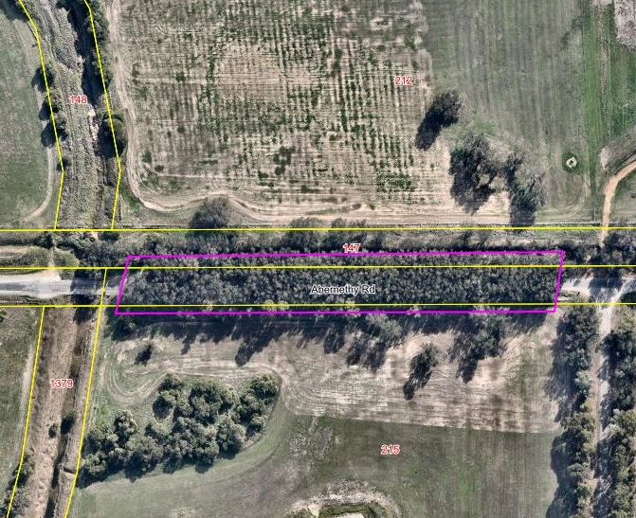

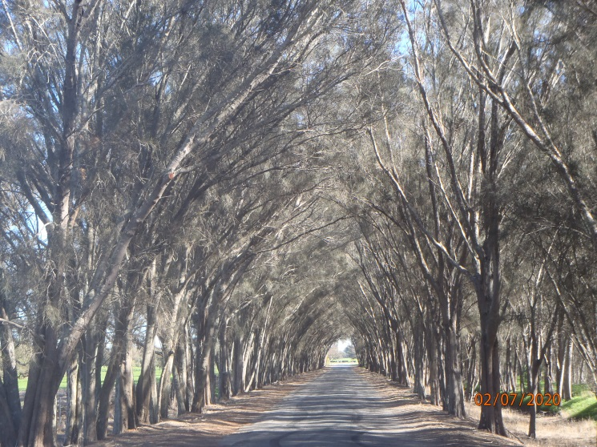
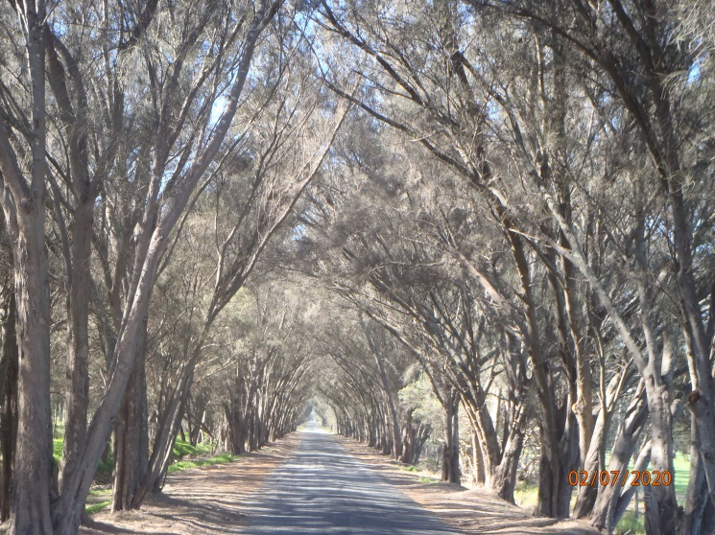

Significant Tree Register – Assessment Report – ST 08

Registry number: ST 08
Species: Corymbia calophylla (marri) and Eucalyptus marginata (jarrah)
Number of trees: 52 (41 marri and 11 jarrah)

Height: up to 22 m
DBH (trunk diameter at 120cm): 10 cm to 117.5 cm
Canopy diameter: up to 12 m
Estimated age: 20 years to 290 years (calculated)

Address: Road reserve, Alice Road, Cardup
Location description: Along the narrow section of Alice Road at the Redcliffe Road end
GPS coordinates: Southern (Redcliffe) end:
32.246499 S, 115.998120 E
Northern end:
32.245594 S, 115.998410 E

Landowner: Crown land, Shire vesting
Category of significance: 1 (aesthetics), 2 (size), 6 (location), 10 (group)
Reasons for inclusion: On Municipal Heritage Register and listed in TPS2 Appendix 7 as a Place of Natural Beauty (protected under clause 7.13). Mature trees with habitat and aesthetic values.
Risk assessment: Future road upgrades, resident complaints. Three removed in 2020 due to hazard (Council decision).
Recommendation: Include on Register because:
- Listed on Municipal Heritage Register
- Listed in TPS2 Appendix 7 as a Place of Natural Beauty
- Mature trees with habitat and aesthetic values

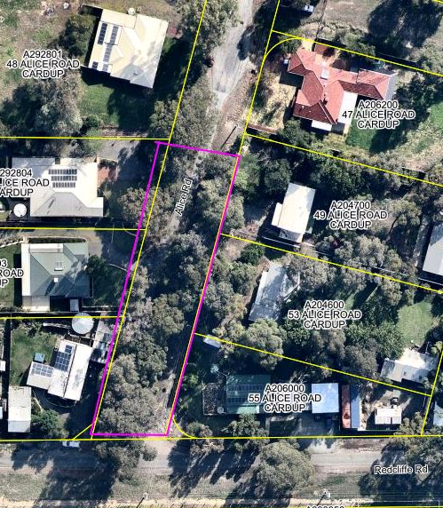
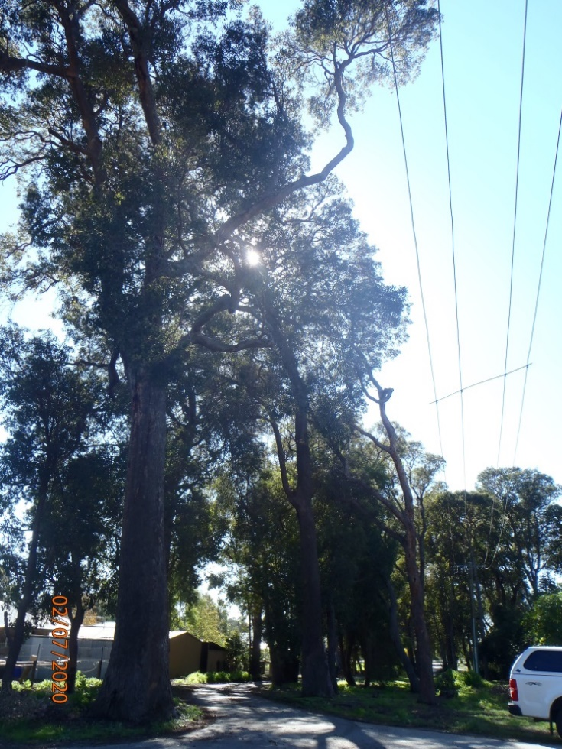
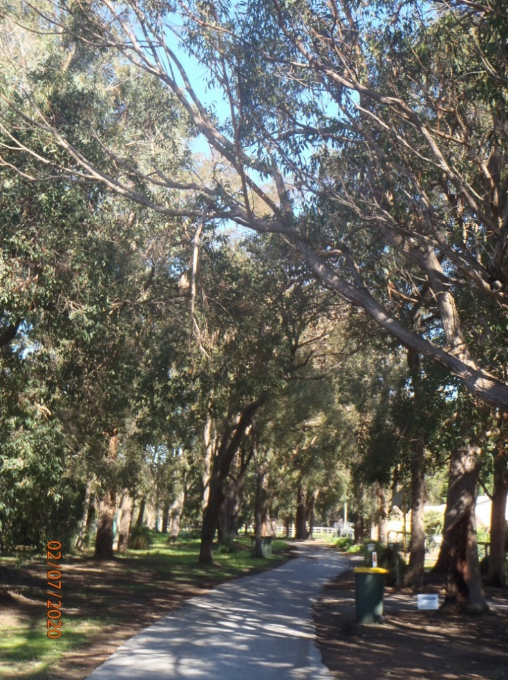

Significant Tree Register – Assessment Report – ST 10

Registry number: ST 10
Species: Corymbia calophylla (marri)
Number of trees: Three

Height: 35 m, 10 m, 25 m
DBH (trunk diameter at 120cm): 123 cm, 67 cm, 83 cm
Canopy diameter: 18 m, 15 m, 15 m
Estimated age: 295, 164, 201 years (calculated)

Address: 172 (L113) Keirnan Street, Whitby
Location description: Group to the northeast of the shed. Four other nominated trees on property.
GPS coordinates:
32.2848029 S, 115.9987558 E
32.2847235 S, 115.9987236 E
32.2847303 S, 115.9988483 E

Landowner: Shire freehold
Category of significance: 1 (aesthetics), 2 (size), 3 (age)
Reasons for inclusion: Attractive, large old trees with high habitat value. First tree has a raven’s nest in the crown. Veldt grass does not grow under canopies (noticeable in all marris on property).
Risk assessment: Development of property, sale by Shire, subdivision. Second tree is leaning heavily, with second trunk removed on upper side, and fungal bodies evident. Third tree has dropped some large branches.
Recommendation: Include Largest Tree Only on Register because:
- Attractive, large old tree with habitat value
- Trees 2 and 3 are not Significant

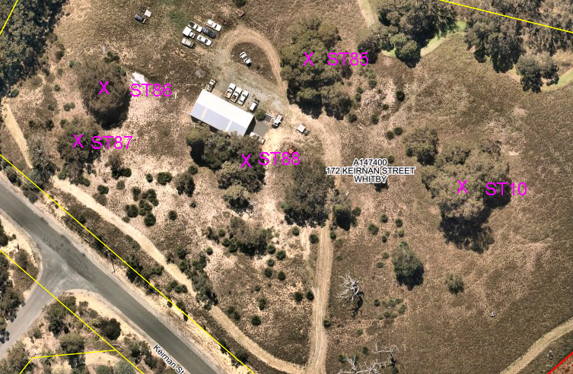

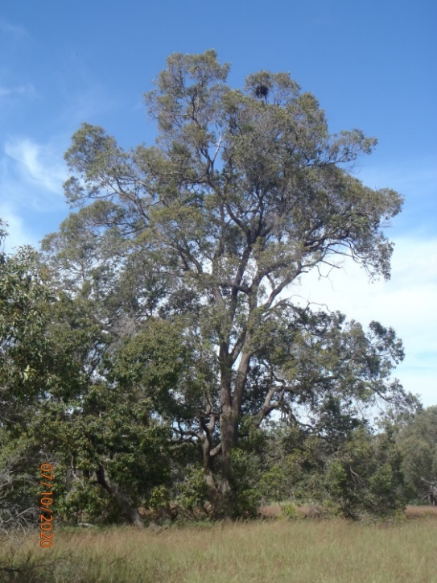
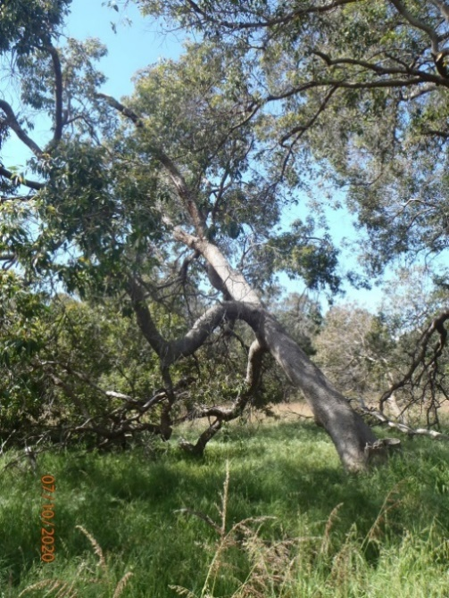
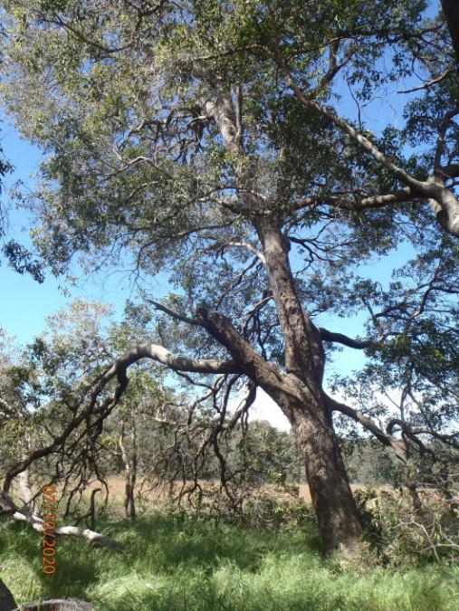

Significant Tree Register – Assessment Report – ST 21

Registry number: ST 21
Species: Eucalyptus rudis (flooded gum)
Number of trees: approx. 350, with 90 large (DBH >50cm), over 400m of road

Height: average 15 m
DBH (trunk diameter at 120cm): 10 cm to >200 cm
Canopy diameter: variable
Estimated age: 5 to 400 years

Address: Road reserve, Rapids Road, Mardella
Location description: Tree tunnel along northern section
GPS coordinates: North end:
32.3354095 S, 115.9451599 E
South end:
32.3382605 S, 115.9444799 E

Landowner: Crown land, Shire vesting
Category of significance: 1 (aesthetics), 10 (avenue)
Reasons for inclusion: Large natural tunnel over road, supporting possums and frogs and creating ecological linkage. Very attractive section of road.
Risk assessment: Future road widening or upgrades, pruning to protect trucks. Canopies are thin, particularly on the larger trees, could be leaf miner, could threaten survival over time if attacks are frequent.
Recommendation: Include on Register because:
- Highly attractive section of road with tree tunnel
- Provides fauna habitat and ecological linkage
- Highly valued by local community

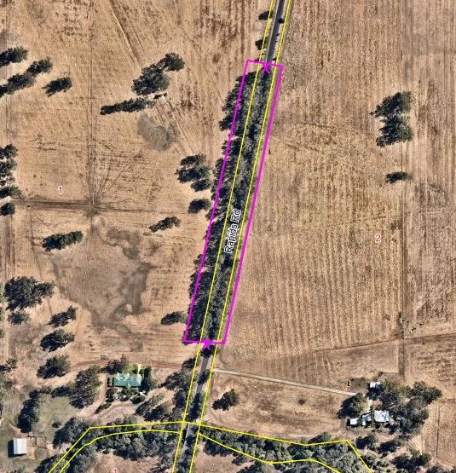
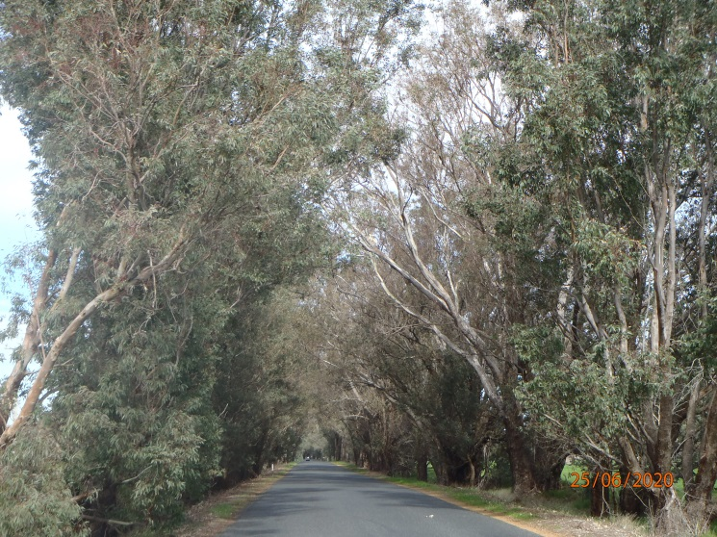

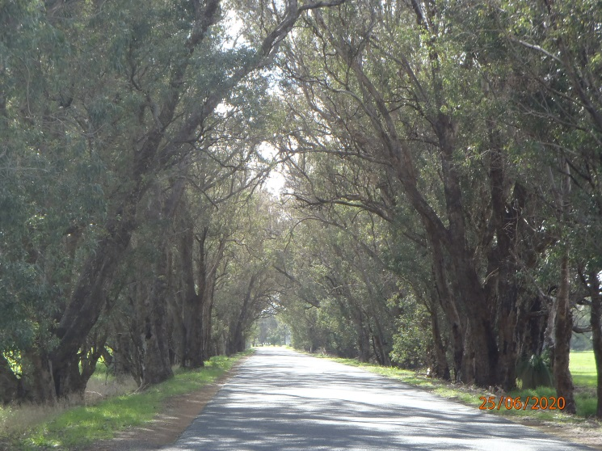

Significant Tree Register – Assessment Report – ST 27

Registry number: ST 27
Species: mostly Casuarina obesa (swamp sheoak) with a few Eucalyptus rudis (flooded gum), Melaleuca preissiana (swamp paperbark) and Corymbia calophylla (marri)
Number of trees: approx. 600 (south of road – approx. 120 sheoaks, 5 marri, 2 flooded gums; north of road – approx. 450 sheoaks, 5 paperbarks, 22 flooded gums)

Height: average 10 m
DBH (trunk diameter at 120cm): average 5 cm to 30 cm, some 60 cm to 100 cm
Canopy diameter: 1 m to 8 m
Estimated age: 2 years to 200 years

Address: Road reserve, Lowlands Road, Mardella
Location description: Tree tunnel on road reserve – easternmost of two tunnels, longest one
GPS coordinates: East: 32.334308 S, 115.961068 E
West: 32.334376 S, 115.957018 E

Landowner: Crown land, Shire vesting
Category of significance: 1 (aesthetics), 10 (avenue)
Reasons for inclusion: Beautiful tree tunnel over road, providing habitat for possums in trees, frogs in drains, and contributing to ecological linkages. Highly valued by local community.
Risk assessment: Road widening or upgrades, pruning to protect trucks. Road is dead-end so traffic is local only.
Recommendation: Include on Register because:
- Beautiful tree tunnel over road
- Habitat for possums, frogs and ecological linkage
- Highly valued by local community

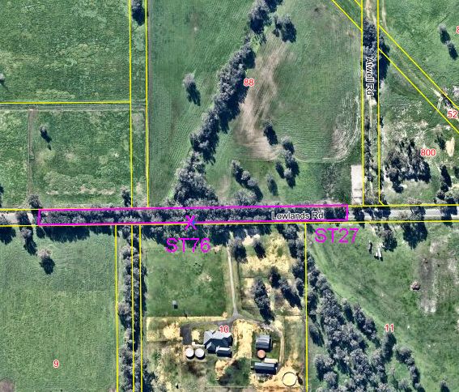

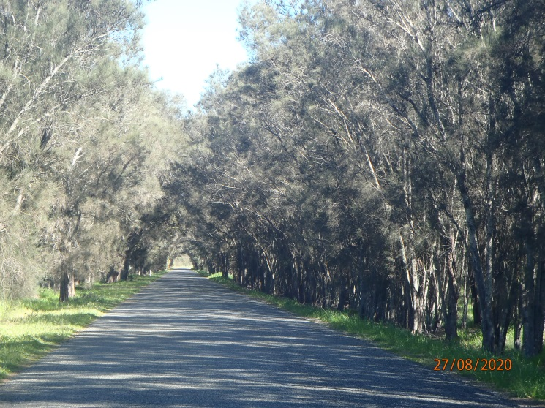
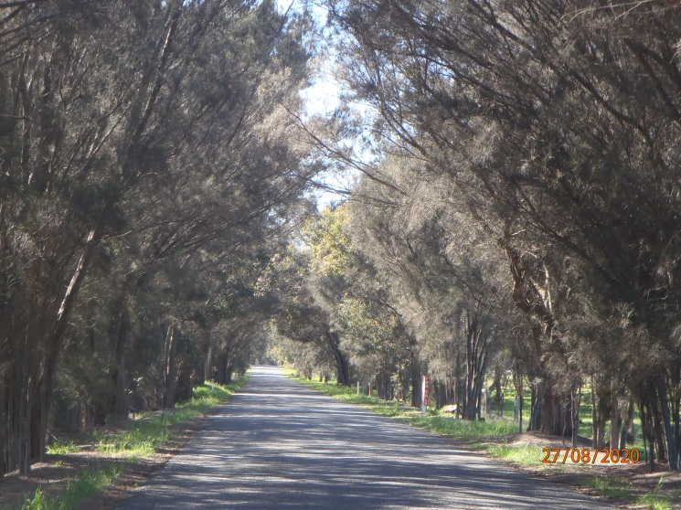

Significant Tree Register – Assessment Report – ST 31

Registry number: ST 31, 56
Species: Eucalyptus marginata (jarrah), Corymbia calophylla (marri), some introduced species including E. robusta (swamp mahogany) and Acacia decurrens (black wattle)
Number of trees: approx. 230 (120 on north side, 110 on south)

Height: average 15-20 m
DBH (trunk diameter at 120cm): mostly 10-80 cm
Canopy diameter: average 5-10 m
Estimated age: 100-200 years

Address: Road reserve, Jarrahdale Road, Jarrahdale
Location description: 200m tree tunnel near entrance to Jarrahdale from South Western Highway
GPS coordinates: West end:
32.320910 S, 116.048738 E
East end: 32.323608 S, 116.050122 E

Landowner: Crown land, Shire vesting
Category of significance: 1 (aesthetics), 6 (location), 10 (avenue)
Reasons for inclusion: Forms a wonderful scenic entry into historic town, tunnel of trees over road.
Risk assessment: Road widening or upgrade, pruning to protect trucks. Signs of canker disease in some marris.
Recommendation: Include on Register because:
- Scenic entry into historic tourist town
- Tree tunnel over road with significance to local community

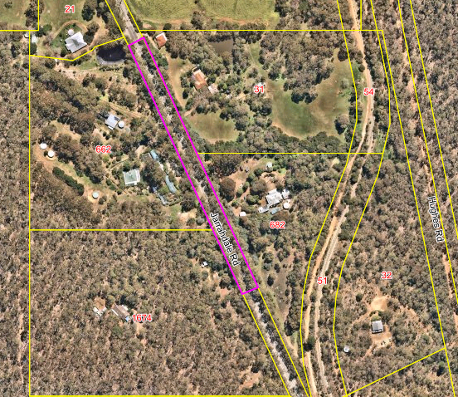
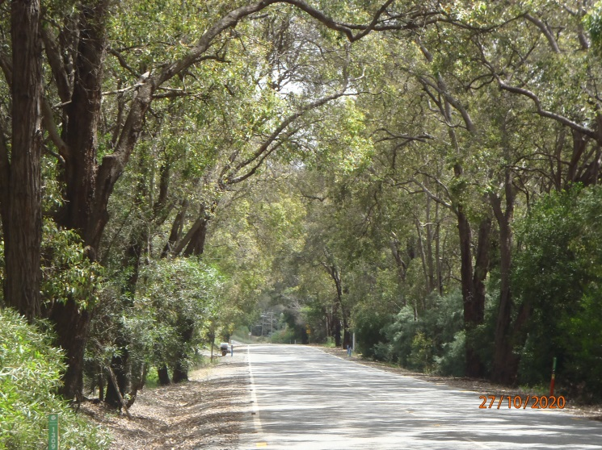
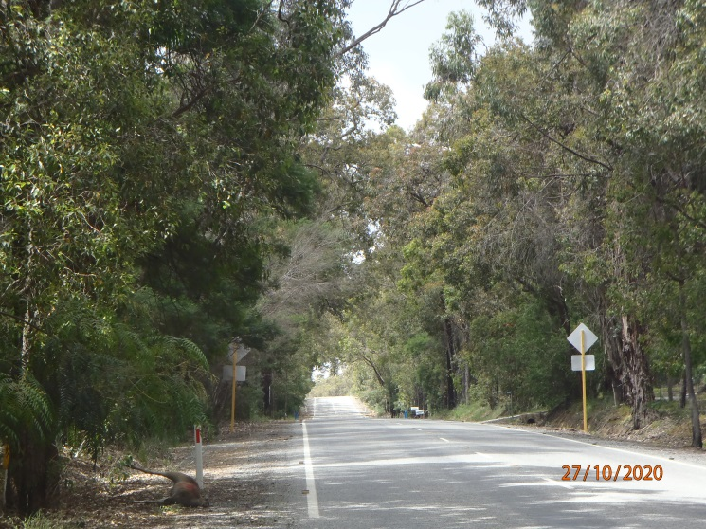

Significant Tree Register – Assessment Report – ST 32

Registry number: ST 32
Species: Eucalyptus camaldulensis (river red gum) x27
Eucalyptus robusta (swamp mahogany) x15
Number of trees: 42

Height: See arborist’s report (E18/1337)
DBH (trunk diameter at 120cm): See arborist’s report
Canopy diameter: See arborist’s report
Estimated age: See arborist’s report

Address: Road reserve, Kokoda Boulevard, Byford
Location description: Western side of Kokoda Boulevard between Kitley Road and Abernethy Road
GPS coordinates: South 32.2227625 S, 115.9819621 E
North 32.2202008 S, 115.9819913 E

Landowner: Crown land, Shire vesting
Category of significance: 1 (aesthetics), 2(size), 3 (age), 6 (location), 10 (avenue)
Reasons for inclusion: Big old trees that beautify the streetscape and demonstrate the previous land uses as fenceline plantings on the farm. Preserved during subdivision and development to provide character to the area.
Risk assessment: Resident complaints of hazard or nuisance. Arborist’s report in 2018 has been followed for management.
Recommendation: Include on Register because:
- Big old trees that provide amenity and character
- Show previous land use as fenceline plantings on farm

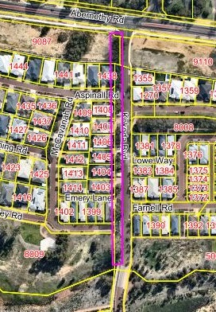

Streetscape (viewed from the north):
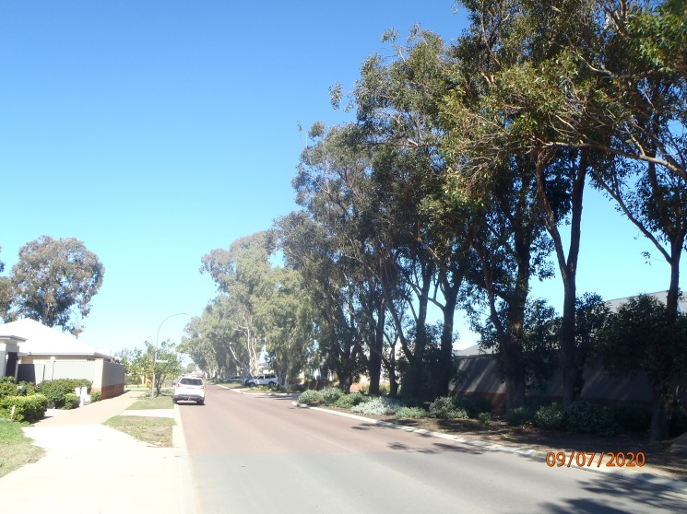

Tree photos from south to north – see table on p. 4 for details and species.

Trees 1 to 8:
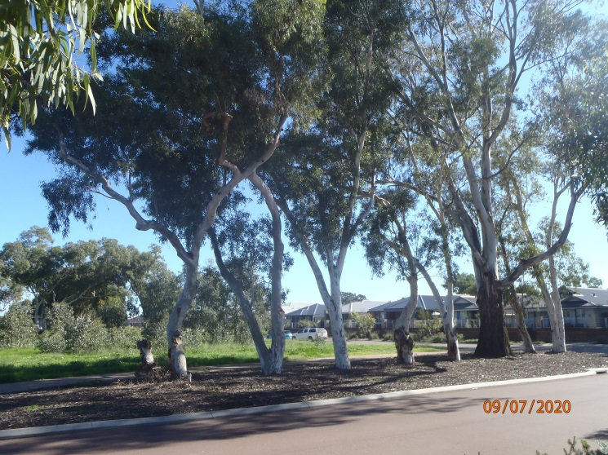

Trees 9 to 12:
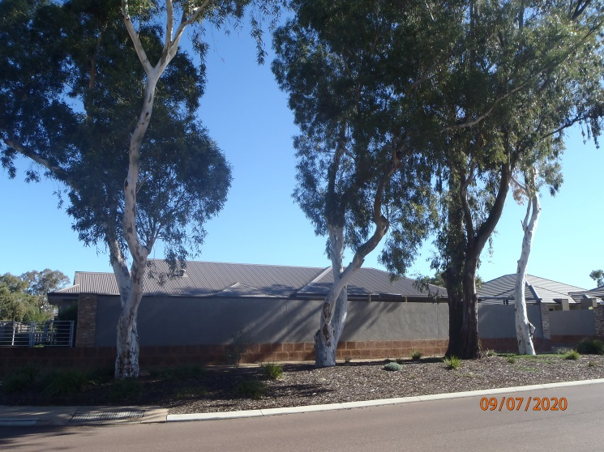

Trees 13 to 14:
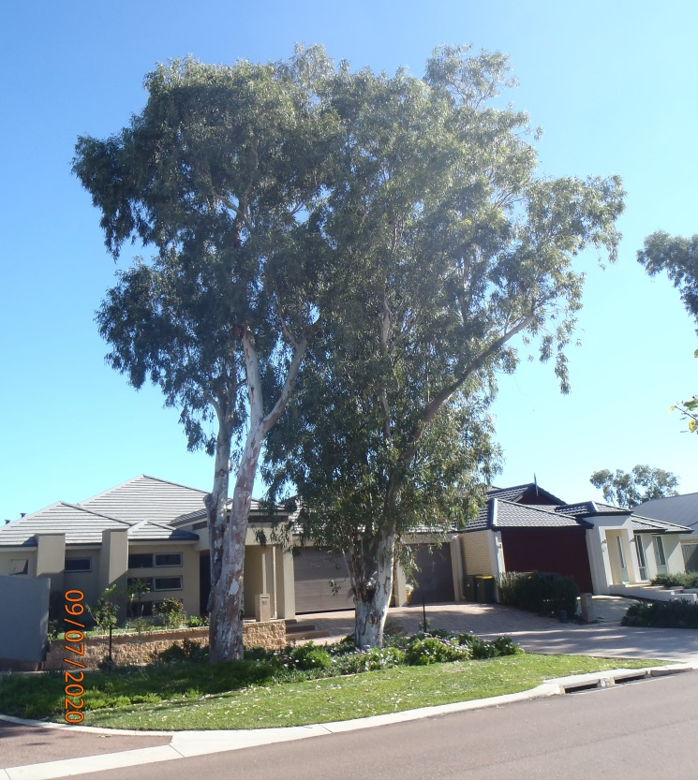

Trees 15 to 18:
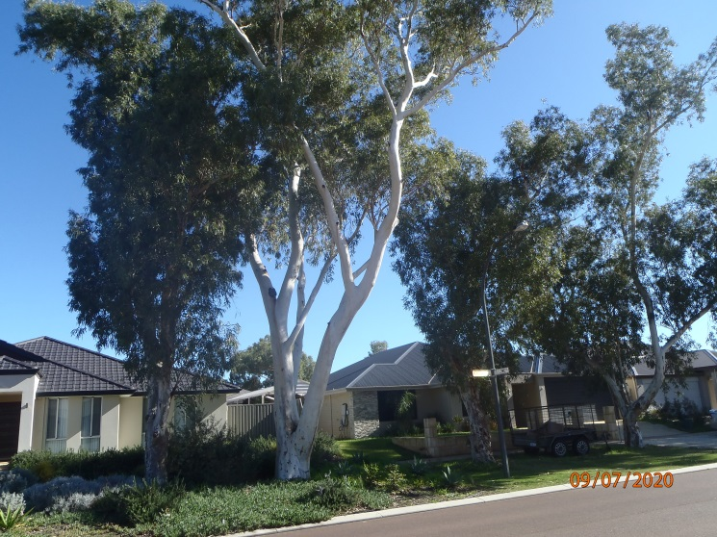

Trees 16 to 18:
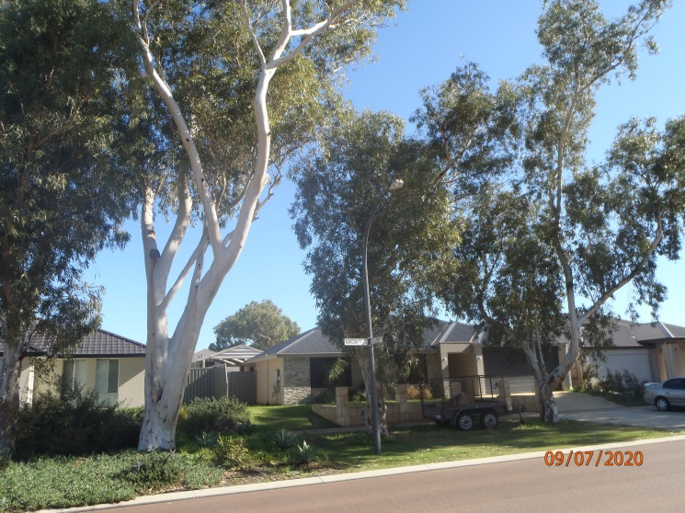

Trees 19 to 24:
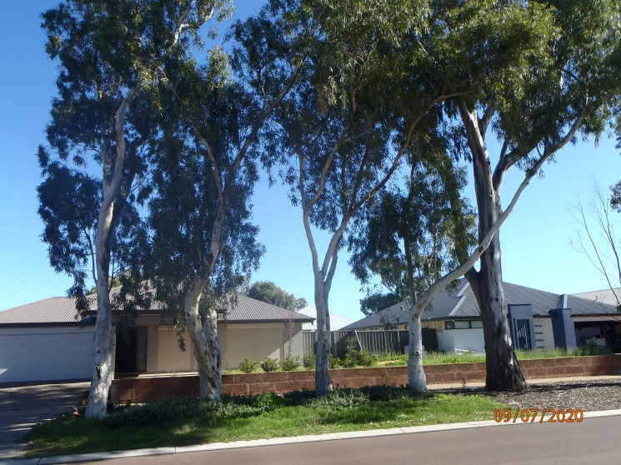

Trees 22 to 25:
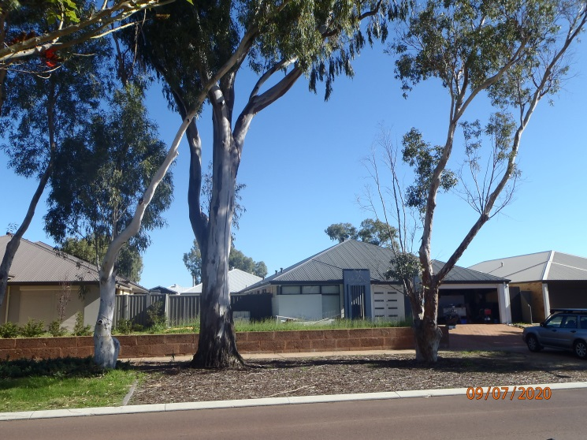

Trees 26 to 28:
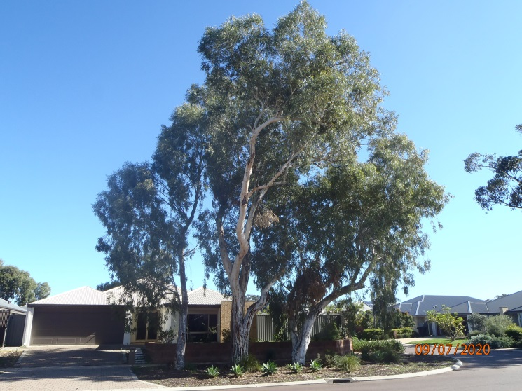

Trees 29 to 33:
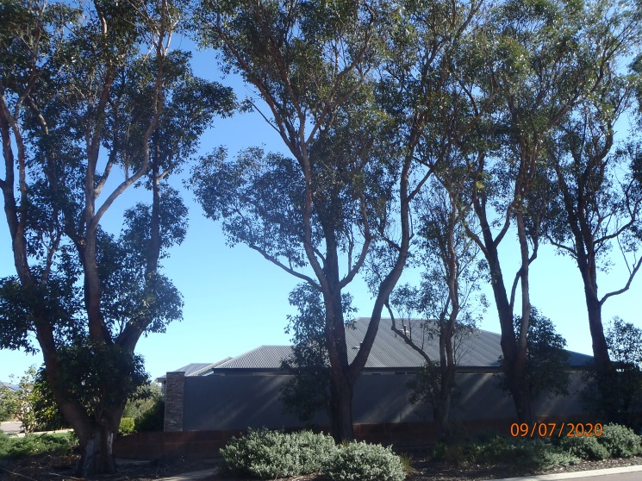

Trees 34 to 38:
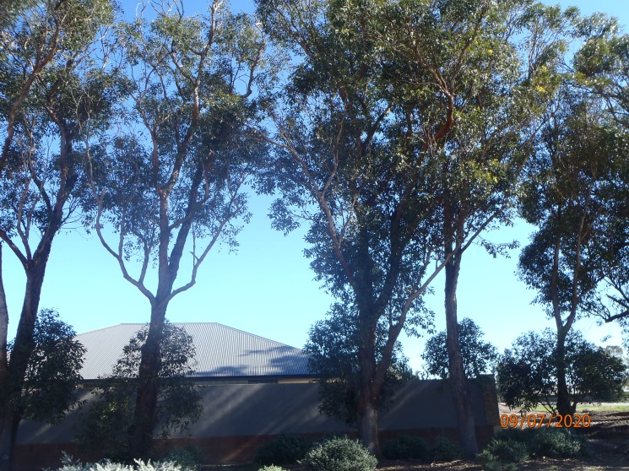

Trees 39 to 43:
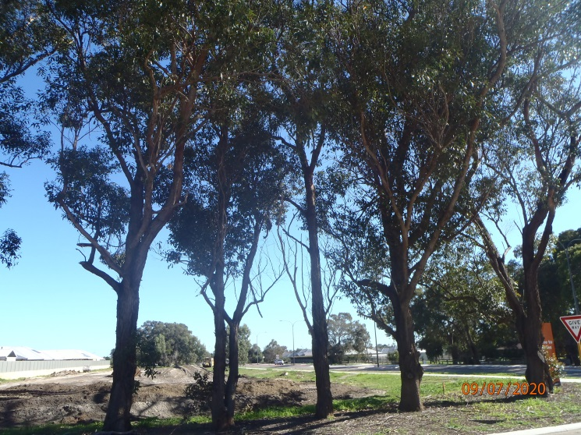

Tree locations, arborist’s report reference (E18/1337) and species
House number | Tree number | Tree number in arborist’s report | Species
Reserve | 1 | Not in report | Eucalyptus camaldulensis var. obtusa
Reserve | 2 | Not in report | Eucalyptus camaldulensis var. obtusa
Reserve | 3 | Not in report | Eucalyptus camaldulensis var. obtusa
Reserve | 4 | Not in report | Eucalyptus camaldulensis var. obtusa
Reserve | 5 | Not in report | Eucalyptus camaldulensis var. obtusa
Reserve | 6 | Not in report | Eucalyptus camaldulensis
Reserve | 7 | Not in report | Eucalyptus camaldulensis var. obtusa
Reserve | 8 | Not in report | Eucalyptus camaldulensis var. obtusa
#2 McCavanah | 9 | 1 | Eucalyptus camaldulensis var. obtusa
#2 McCavanah | 10 | 3 | Eucalyptus camaldulensis var. obtusa
#2 McCavanah | 11 | 4 | Eucalyptus camaldulensis
#2 McCavanah | 12 | 5 | Eucalyptus camaldulensis var. obtusa
#16 Kokoda | 13 | 7 | Eucalyptus camaldulensis var. obtusa
#16 Kokoda | 14 | 8 | Eucalyptus camaldulensis var. obtusa
#14 Kokoda | 15 | 10 | Eucalyptus camaldulensis var. obtusa
#14 Kokoda | 16 | 11 | Eucalyptus camaldulensis var. obtusa
#12 Kokoda | 17 | 13 | Eucalyptus camaldulensis var. obtusa
#12 Kokoda | 18 | 15 | Eucalyptus camaldulensis
#10 Kokoda | 19 | 16 | Eucalyptus camaldulensis var. obtusa
#10 Kokoda | 20 | 17 | Eucalyptus camaldulensis var. obtusa
#10 Kokoda | 21 | 18 | Eucalyptus camaldulensis var. obtusa
#10 Kokoda | 22 | 19 | Eucalyptus camaldulensis var. obtusa
#8 Kokoda | 24 | 20 | Eucalyptus camaldulensis
#8 Kokoda | 25 | 22 | Eucalyptus camaldulensis var. obtusa
#6 Kokoda | 26 | 24 | Eucalyptus camaldulensis var. obtusa
#6 Kokoda | 27 | 25 | Eucalyptus camaldulensis var. obtusa
#6 Kokoda | 28 | 26 | Eucalyptus camaldulensis var. obtusa
#2 Aspinall | 29 | Not in report | Eucalyptus robusta
#2 Aspinall | 30 | Not in report | Eucalyptus robusta
#2 Aspinall | 31 | Not in report | Eucalyptus robusta
#2 Aspinall | 32 | Not in report | Eucalyptus robusta
#2 Aspinall | 33 | Not in report | Eucalyptus robusta
#2 Aspinall | 34 | Not in report | Eucalyptus robusta
#2 Aspinall | 35 | Not in report | Eucalyptus robusta
#2 Aspinall | 36 | Not in report | Eucalyptus robusta
#2 Aspinall | 37 | Not in report | Eucalyptus robusta
#2 Aspinall | 38 | Not in report | Eucalyptus robusta
#2 Aspinall | 39 | Not in report | Eucalyptus robusta
#2 Aspinall | 40 | Not in report | Eucalyptus robusta
#2 Aspinall | 41 | Not in report | Eucalyptus robusta
#2 Aspinall | 42 | Not in report | Eucalyptus robusta
#2 Aspinall | 43 | Not in report | Eucalyptus robusta

Significant Tree Register – Assessment Report – ST 34

Registry number: ST 34, 55
Species: Eucalyptus marginata (jarrah)
Number of trees: One

Height: 28 m
DBH (trunk diameter at 120cm): 220.5 cm
Canopy diameter: 22 m
Estimated age: 524 years (calculated)

Address: Road reserve, Jarrahdale Road, Jarrahdale
Location description: 420 m east of Balmoral Road turnoff, on north side of road
GPS coordinates: 32.3360141 S, 116.0780552 E

Landowner: Crown land, Shire or DBCA vesting (boundary unclear)
Category of significance: 1 (aesthetics), 2 (size), 3 (age), 9 (unique features)
Reasons for inclusion: Very old, large jarrah with habitat hollows. Wonderful example of tree left by early loggers due to special features, burls, not straight, burnt hollows in base.
Risk assessment: Future road widening or upgrades – retained and protected during recent road upgrades. Some termite activity in hollows.
Recommendation: Include on Register because:
- Very large, old jarrah with habitat hollows
- Wonderful example of tree left by early loggers due to special features
- Many burls, two burnt hollows in base

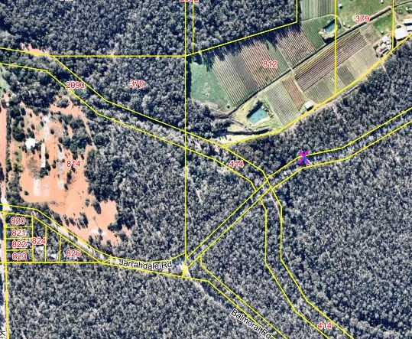

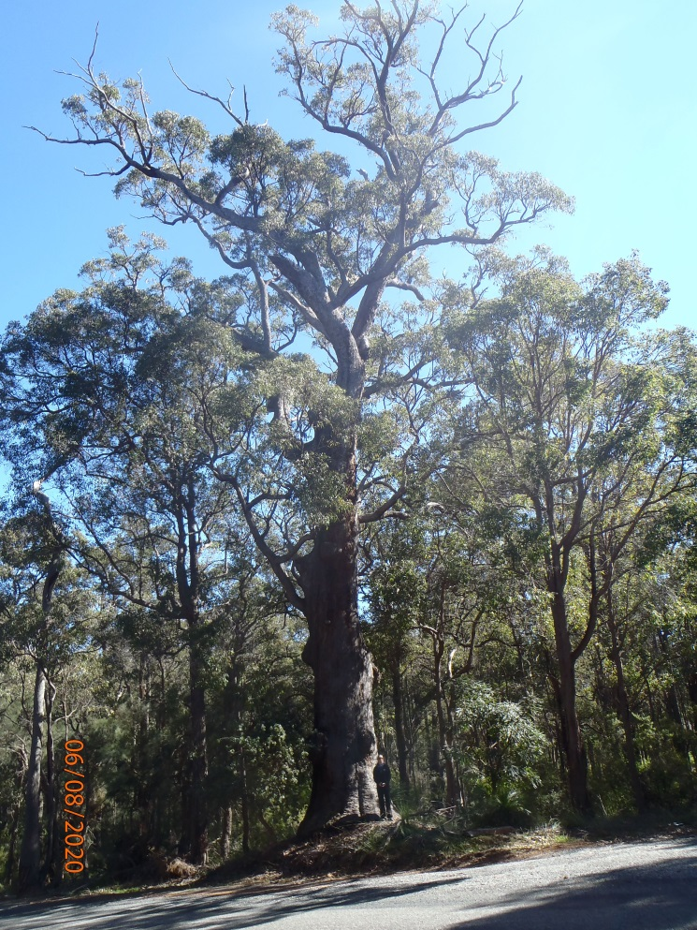
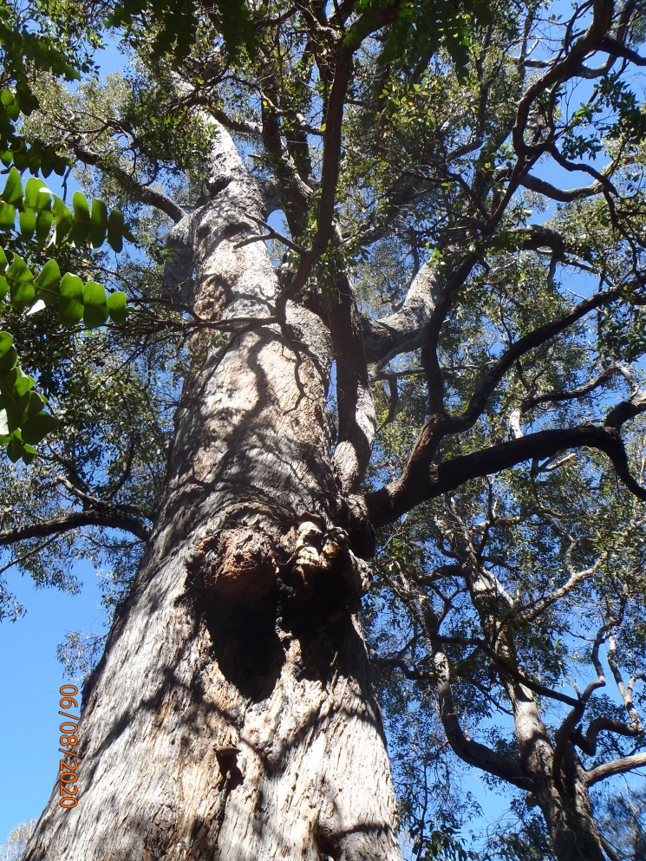

Significant Tree Register – Assessment Report – ST 36

Registry number: ST 36
Species: Eucalyptus wandoo (wandoo)
Number of trees: One

Height: 18 m
DBH (trunk diameter at 120cm): 86 cm
Canopy diameter: 10 m
Estimated age: 200 years

Address: R23328, L350 Elliott Road, Keysbrook
Location description: North-western corner of lot
GPS coordinates: 32.438382 S, 115.978619 E

Landowner: Unallocated Crown land, soon to be Shire vested
Category of significance: 2 (size), 3 (age), 5 (ethnic association)
Reasons for inclusion: Registered Aboriginal scar tree. Old mature wandoo with habitat hollows.
Risk assessment: Development, control burning. Has dropped some branches but otherwise very healthy. Termite mound at base. Within an unmade road reserve which is not required unless lot is subdivided.
Recommendation: Include on Register because:
- Registered Aboriginal scar tree
- Old tree with habitat hollows

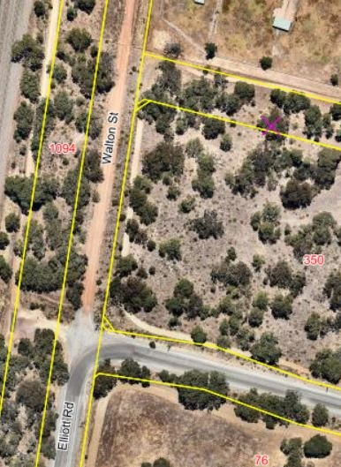
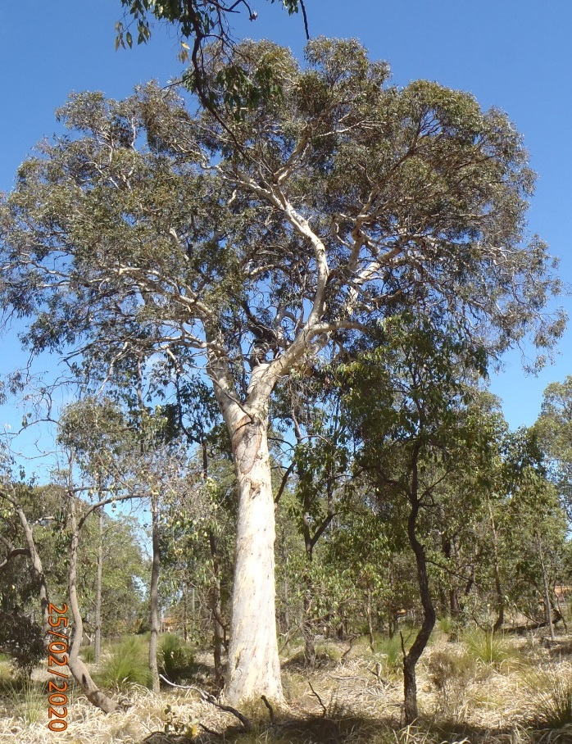
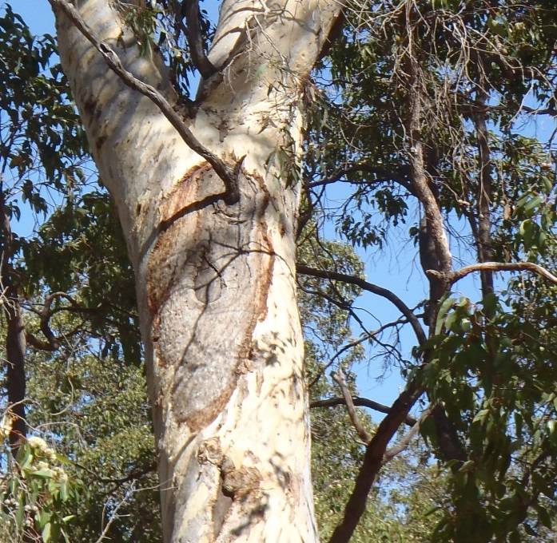

Significant Tree Register – Assessment Report – ST 37

Registry number: ST 37
Species: Eucalyptus wandoo (wandoo)
Number of trees: One

Height: 15 m
DBH (trunk diameter at 120cm): 74.5 cm
Canopy diameter: 12 m
Estimated age: 200 years

Address: R23328, L350 Elliott Road, Keysbrook
Location description: South-eastern corner of lot
GPS coordinates: 32.439349 S, 115.979191 E

Landowner: Unallocated Crown land, soon to be Shire vested
Category of significance: 2 (size), 3 (age), 5 (ethnic association)
Reasons for inclusion: Registered Aboriginal scar tree. Old mature wandoo with habitat hollows.
Risk assessment: Development, control burning. Has dropped some branches but otherwise very healthy.
Recommendation: Include on Register because:
- Registered Aboriginal scar tree
- Old tree with habitat hollows

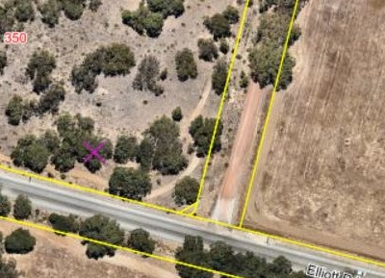

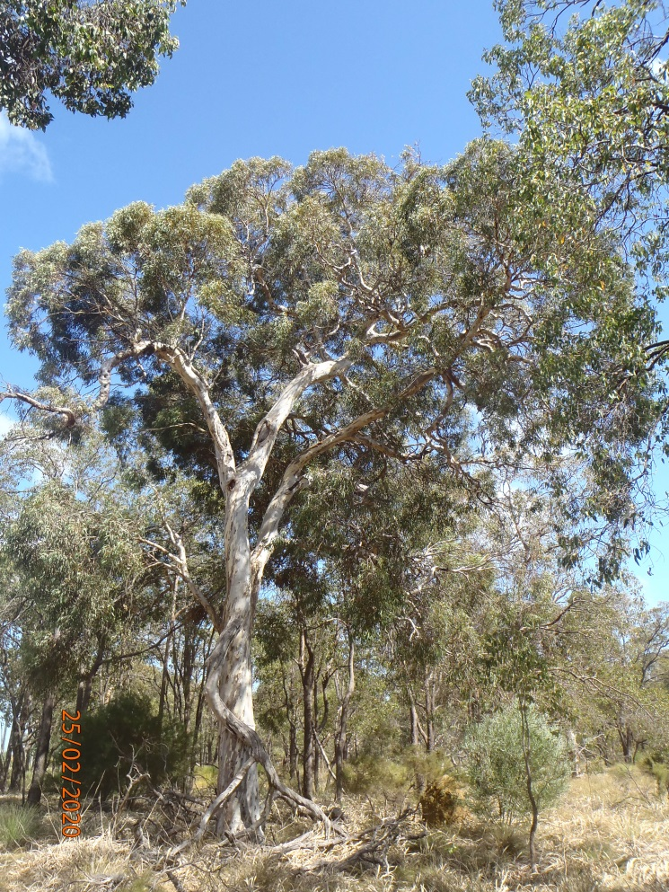
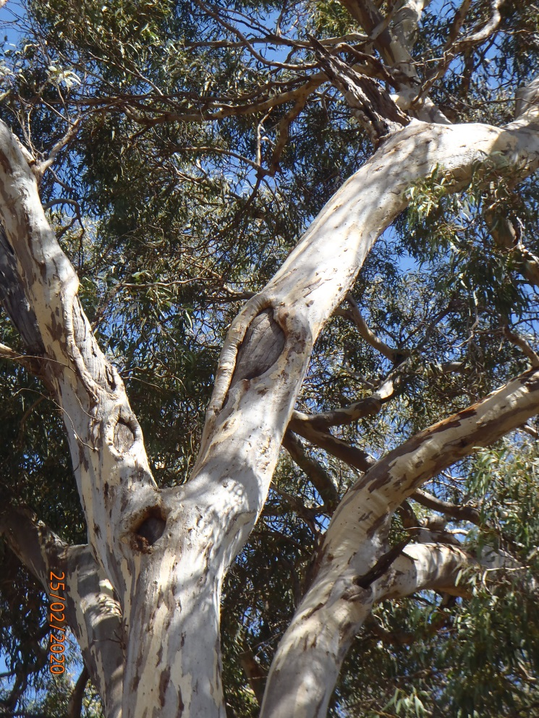

Significant Tree Register – Assessment Report – ST 38-39

Registry number: ST 38-39
Species: Melaleuca preissiana (swamp paperbark)
Number of trees: Two

Height: 15 m
DBH (trunk diameter at 120cm): 99.5 cm (ST 38)
85.5 cm below fork, 81 cm and 28 cm above (ST 39)
Canopy diameter: 12 m
Estimated age: 200 years

Address: R41485 (L1393) Foxton Drive, Oakford
Location description: Western boundary, just north of the central firebreak (ST 38 is north of ST 39)
GPS coordinates: ST 38: 32.1884921 S, 115.9145062 E
ST 39: 32.1885784 S, 115.9145746 E

Landowner: Crown land, Shire vesting
Category of significance: 2 (size), 3 (age)
Reasons for inclusion: Old, large paperbarks with habitat hollows
Risk assessment: Firebreak maintenance, control burning. Burnt in recent control burns; ST39 retained canopy but ST38 was nearly killed (has recovered but retains staghorns from canopy fire)
Recommendation: Include on Register because:
- Very old, large paperbarks with habitat hollows

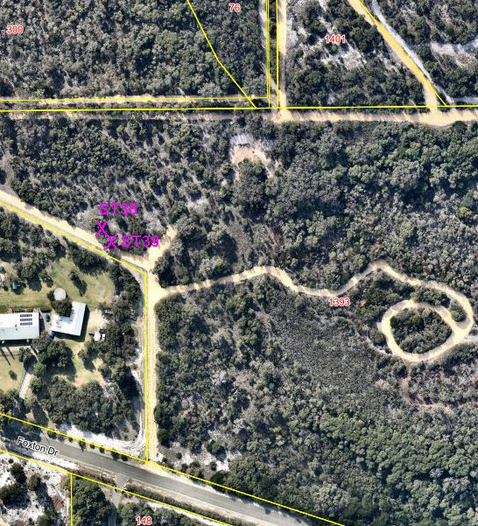

ST 38:
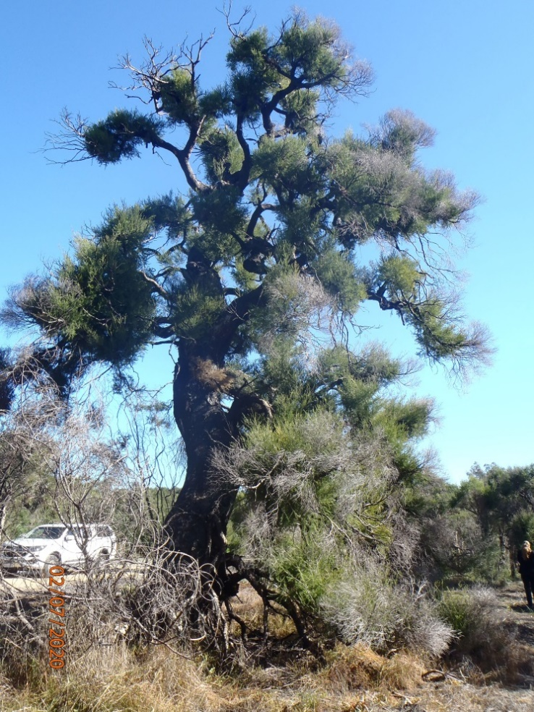

ST 39:
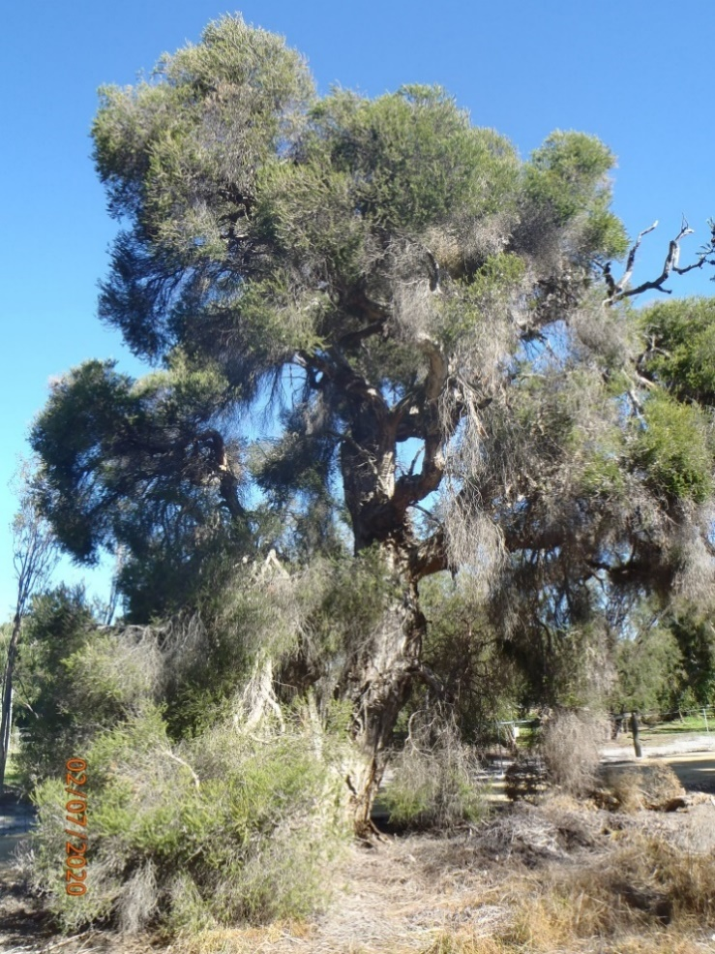

Significant Tree Register – Assessment Report – ST 41

Registry number: ST 41
Species: Eucalyptus marginata (jarrah)
Number of trees: One

Height: 18 m
DBH (trunk diameter at 120cm): 162 cm, 36 cm,
33 cm, 19 cm (multi-trunked)
Canopy diameter: 18 m
Estimated age: 387 years (calculated)

Address: Road reserve, Cardup Siding Road, Cardup
Location description: Southern side of road, opposite Macleod Court
GPS coordinates: 32.2414339 S, 115.9952477 E

Landowner: Crown land, Shire vesting
Category of significance: 2 (size), 3 (age)
Reasons for inclusion: Very old, large jarrah with habitat hollows
Risk assessment: Very close to the edge of the road. Road widening and upgrades. Recently protected during road upgrade. Big scar on trunk and some dead branches but otherwise healthy.
Recommendation: Include on Register because:
- Very old and large tree with habitat hollows

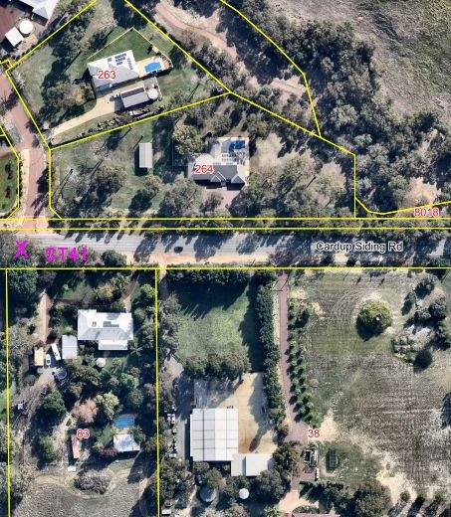

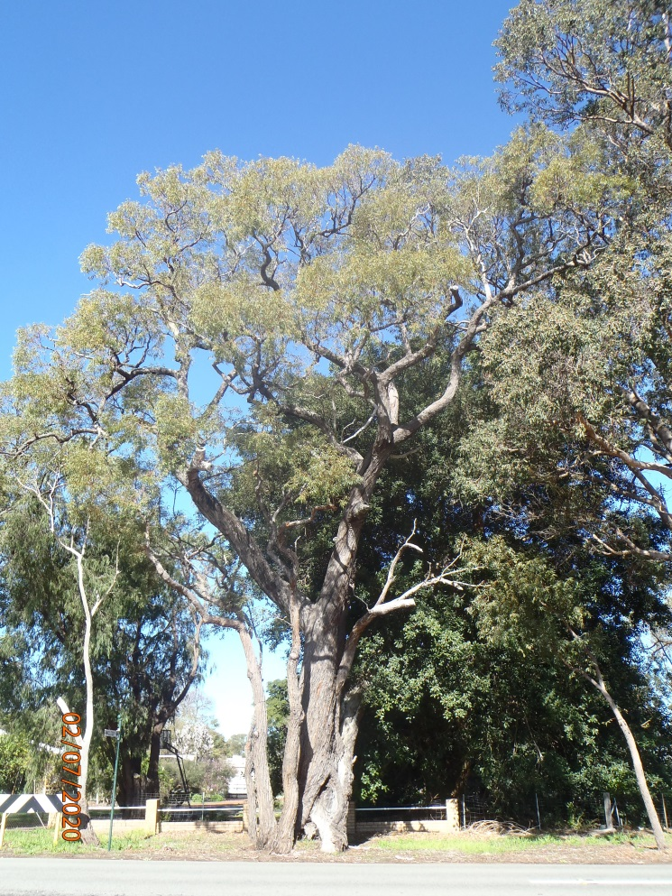

Significant Tree Register – Assessment Report – ST 42

Registry number: ST 42
Species: Eucalytpus marginata (jarrah)
Number of trees: One

Height: 15 m
DBH (trunk diameter at 120cm): 154.5 cm
Canopy diameter: 14 m
Estimated age: 369 years (calculated)

Address: Road reserve, Cardup Siding Road, Cardup
Location description: Southern side of road, about 35m west of Macleod Court
GPS coordinates: 32.2414345 S, 115.9950579 E

Landowner: Crown land, Shire vesting
Category of significance: 2 (size), 3 (age)
Reasons for inclusion: Very old, large jarrah with habitat hollows
Risk assessment: Very close to the edge of the road. Road widening and upgrades. Recently protected during road upgrade. Staghorns, several bee hives in hollows, otherwise healthy.
Recommendation: Include on Register because:
- Very old and large tree with habitat hollows

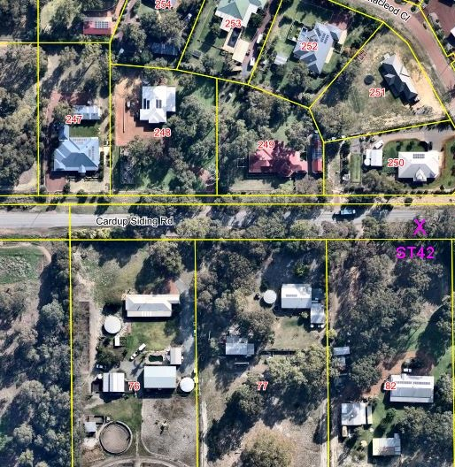

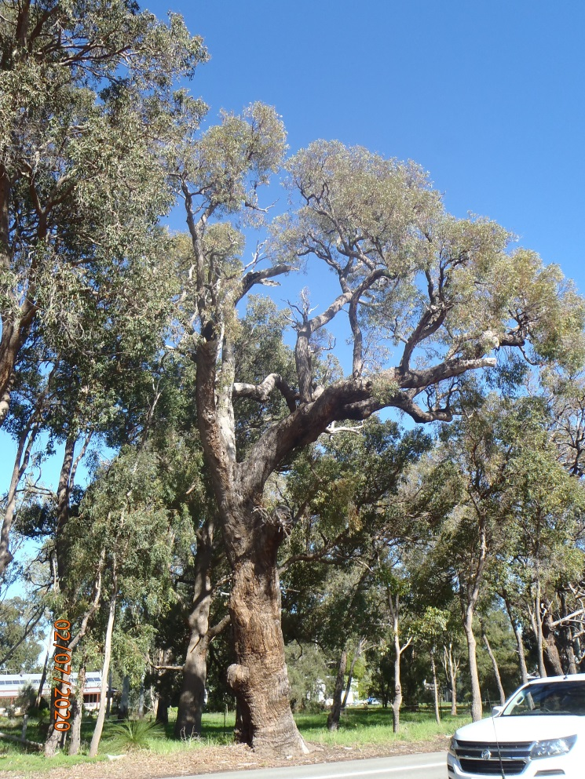

Significant Tree Register – Assessment Report – ST 43

Registry number: ST 43
Species: Eucalyptus marginata (jarrah)
Number of trees: One

Height: 18 m
DBH (trunk diameter at 120cm): 141 cm, 26 cm, 22 cm (multi-trunked)
Canopy diameter: 20 m
Estimated age: 337 years (calculated)

Address: R22020 (L205) Baskerville Road, Mundijong
Location description: Centre of Tonkin Street Flora Reserve, near the central firebreak
GPS coordinates: 32.2849503 S, 115.9833854 E

Landowner: Crown land, Shire vesting
Category of significance: 2 (size), 3 (age)
Reasons for inclusion: Very large, old jarrah with habitat hollows
Risk assessment: Control burning, vandalism by local kids (steps cut into trunk). Recently burnt, canopy declining, fire got into scars which are getting deeper. Some evidence of termites.
Recommendation: Include on Register because:
- Very large, old jarrah with habitat hollows

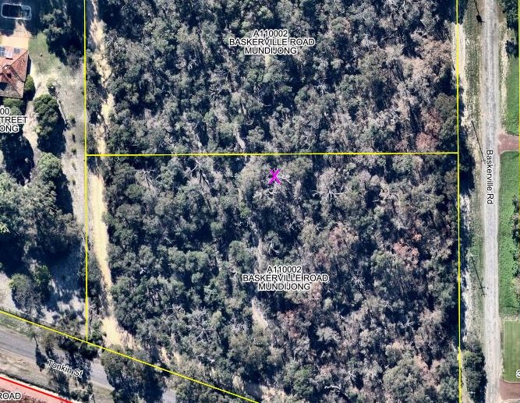

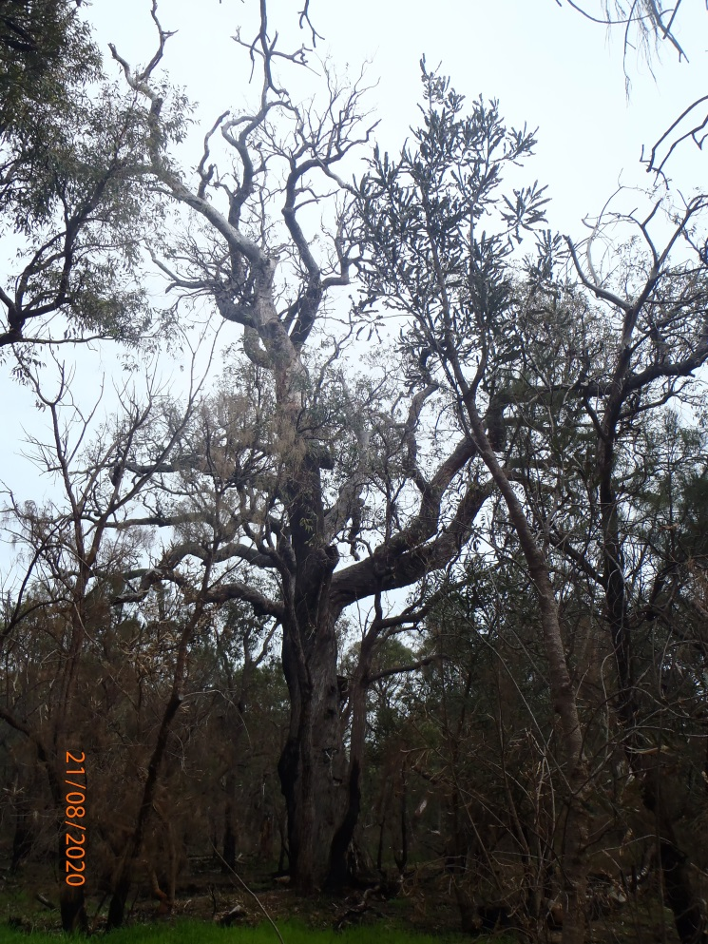

Significant Tree Register – Assessment Report – ST 44

Registry number: ST 44
Species: Eucalyptus marginata (jarrah)
Number of trees: One

Height: 18 m
DBH (trunk diameter at 120cm): 133 cm, 37 cm (double trunked)
Canopy diameter: 19 m
Estimated age: 318 years (calculated)

Address: R6168, 2(L59) Keirnan Street, Mundijong
Location description: Bella Cumming Reserve, in the middle
GPS coordinates: 32.2829911 S, 115.9888021 E

Landowner: Crown land, Shire vesting
Category of significance: 2 (size), 3 (age)
Reasons for inclusion: Large, old jarrah with habitat hollows. Beautiful twisting branches.
Risk assessment: Control burning. Burnt out basal hollow. Has dropped some large limbs recently.
Recommendation: Include in Register because:
- Large, old jarrah with habitat hollows
- Beautiful twisting branches

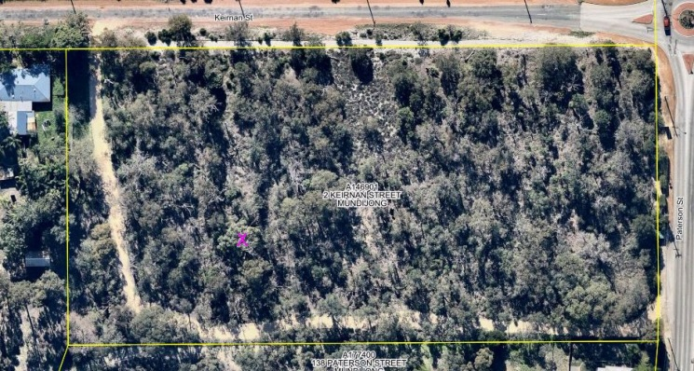

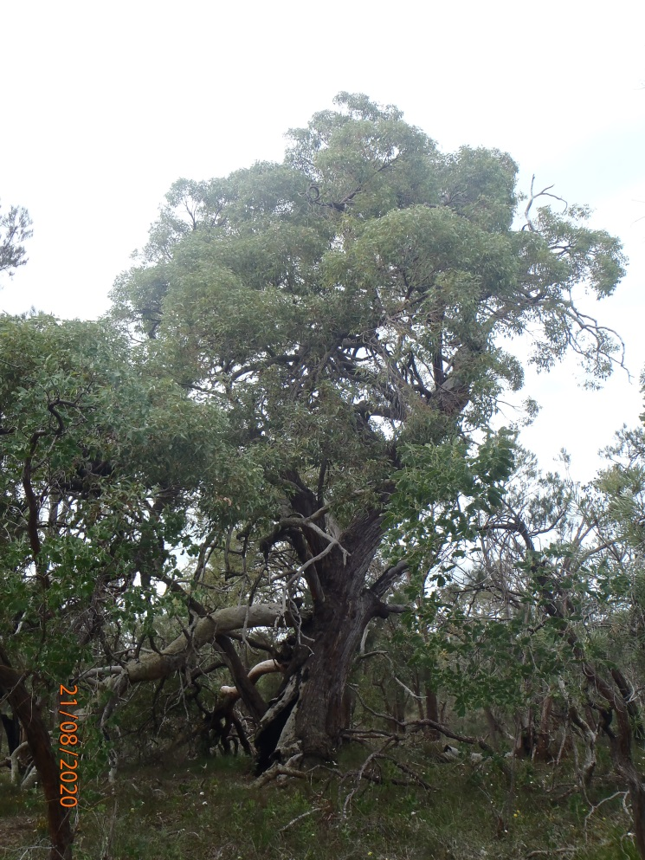
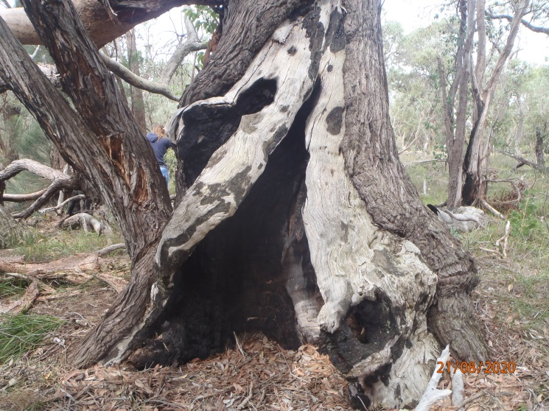

Significant Tree Register – Assessment Report – ST 46

Registry number: ST 46
Species: Prunus armeniaca (apricot)
Number of trees: Two

Height: west 6 m, east 7 m
DBH (trunk diameter at 120cm): west 62 cm at base, 35.5 cm above removed branches; east 84 cm at base, branches 45 cm, 38 cm, 29 cm
Canopy diameter: west 7 m, east 12 m
Estimated age: 150 years

Address: 745 (L814) Jarrahdale Road, Jarrahdale
Location description: Adjacent to RV park entry, east of the fence, 55 m from Jarrahdale Road
GPS coordinates: West 32.336626 S, 116.069880 E
East 32.226635 S, 116.069963 E

Landowner: Crown land, Shire vesting
Category of significance: 3 (age), 4 (historical)
Reasons for inclusion: Planted by early settlers of Jarrahdale. Both have been well pruned in the past.
Risk assessment: Tourism, development of site. West tree has had large hollow branches removed at 50cm and 80cm, otherwise healthy. East tree has termite activity and extensive fungal bodies to more than 3m, threatening its stability over time.
Recommendation: Include on Register because:
- Planted by early settlers of Jarrahdale

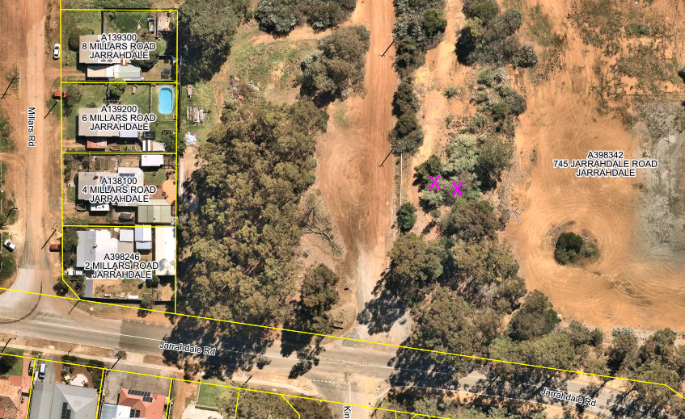

Western tree:
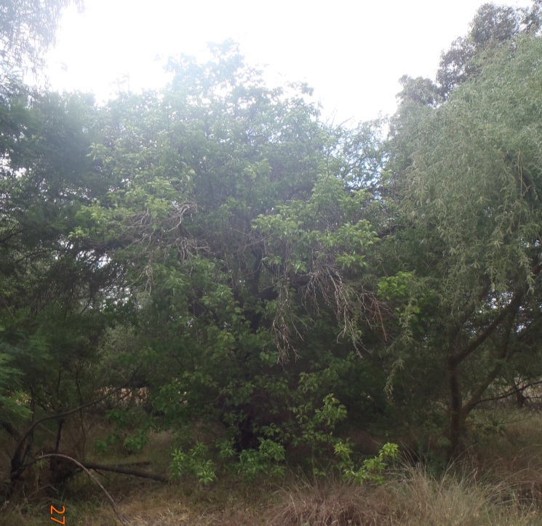

Eastern tree:
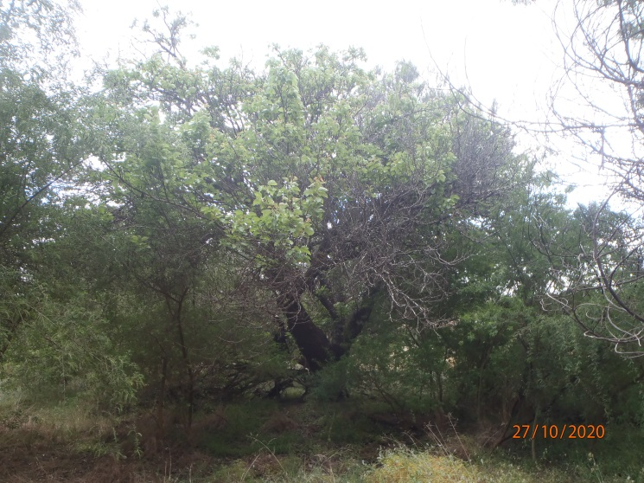

Significant Tree Register – Assessment Report – ST 63

Registry number: ST 63
Species: Eucalyptus lane-poolei (salmon-barked white gum)
Number of trees: One

Height: 18 m
DBH (trunk diameter at 120 cm): multistemmed – 77.5 cm, 31 cm, 20.5 cm, 14 cm, 11 cm, 9.5 cm
Canopy diameter: 15 m
Estimated age: 300 years

Address: R23328 (L350) Elliott Road, Keysbrook
Location description: North-eastern corner of lot
GPS coordinates: 32.438649 S, 115.979411 E

Landowner: Unallocated Crown land, soon to be Shire vested
Category of significance: 2 (size), 3 (age), 7 (localised distribution – local icon)
Reasons for inclusion: Old mature salmon-barked white gum with habitat hollows. Local icon under the biodiversity strategy. One of the largest of its species in the Shire.
Risk assessment: Development, control burning. Has dropped some branches but otherwise very healthy. Multistemmed habit is characteristic of species.
Recommendation: Include on Register because:
- Local icon under the biodiversity strategy
- One of the largest of its species in the Shire
- Old tree with habitat hollows

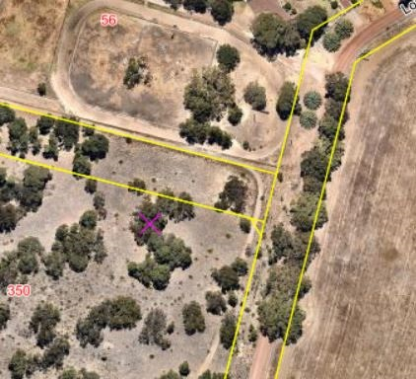

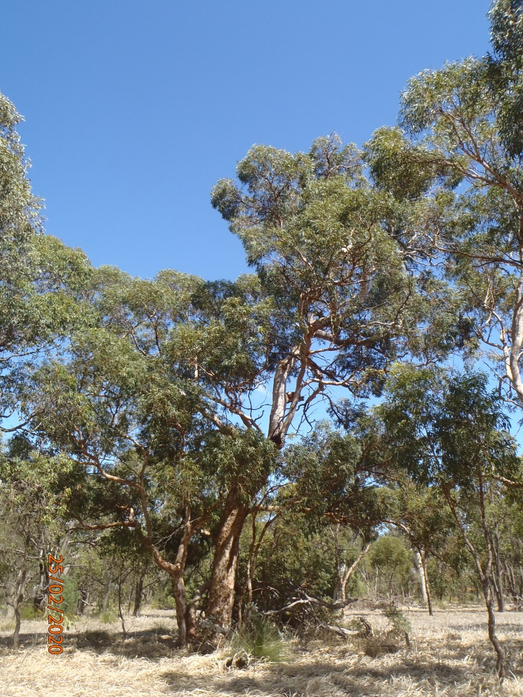

Significant Tree Register – Assessment Report – ST 66

Registry number: ST 66
Species: Eucalyptus x mundijongensis
Number of trees: One

Height: 8 m
DBH (trunk diameter at 120cm): 35 cm
Canopy diameter: 7 m
Estimated age: 30 years

Address: R14609, 27 (L6) Wanliss Street, Jarrahdale
Location description: At Bruno Gianatti Hall, in the southwestern corner, close to the driveway, playground and primary school
GPS coordinates: 32.3380144 S, 116.0621894 E

Landowner: Crown land, Shire vesting
Category of significance: 7 (rare variety)
Reasons for inclusion: Very rare natural hybrid, named for the locality
Risk assessment: Poor health – canopy is thin and uneven, with lots of dead twigs
Recommendation: Include on Register because:
- Very rare natural hybrid, named for the locality

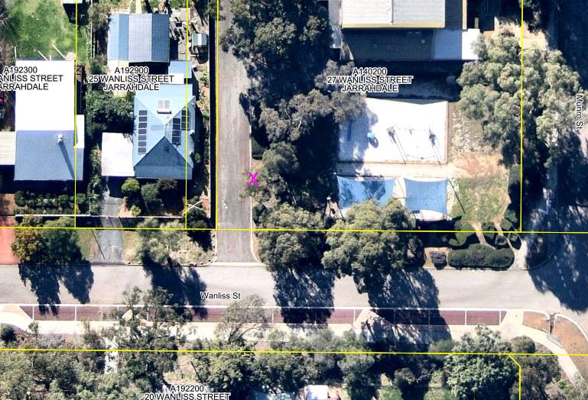

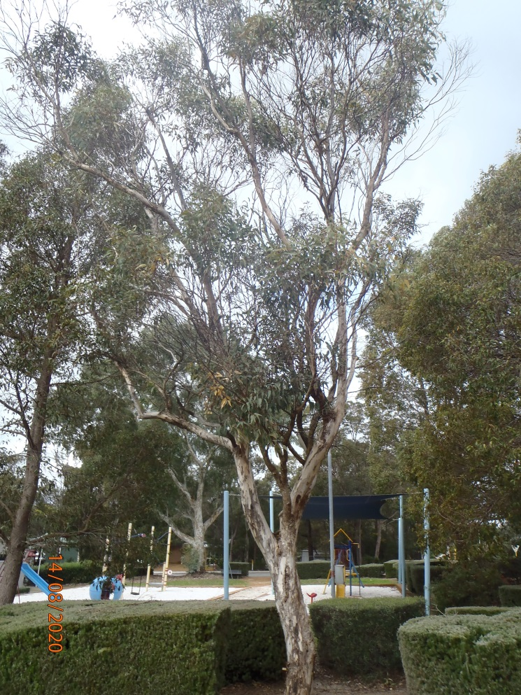
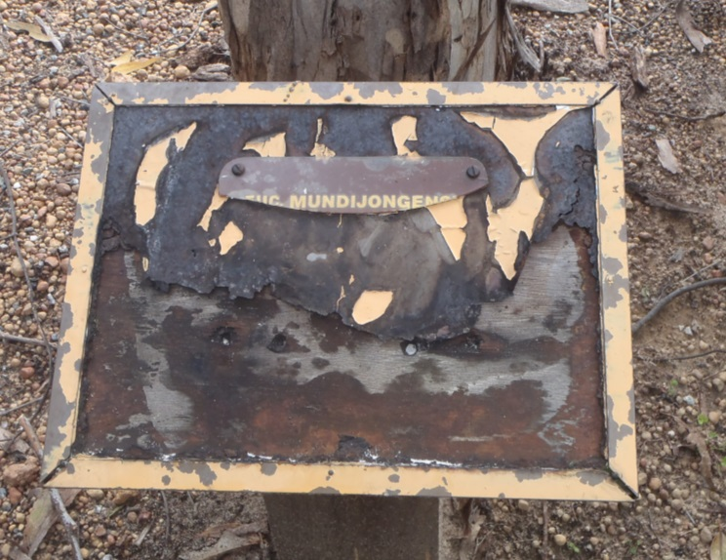

Significant Tree Register – Assessment Report – ST 68

Registry number: ST 68
Species: Corymbia calophylla (marri)
Number of trees: One

Height: 10 m
DBH: 99 cm
Canopy diameter: 12 m
Estimated age: 240 years (calculated)

Address: R52856, 117 (L8047) Kokoda Boulevard, Byford
Location description: South of the football posts
GPS coordinates: 32.2298991 S, 115.9824751 E

Landowner: Crown land, Shire vesting
Category of significance: 1 (aesthetics), 2 (size), 3 (age)
Reasons for inclusion: Beautiful old native tree, children climb the leaning trunk, provides shade, attracts black cockatoos
Risk assessment: Leans heavily to the north. Damage from climbing kids, root compaction, old chopped steps (mostly healed). Large old scar underneath.
Recommendation: Include on Register because:
- Beautiful old tree with habitat value
- Provides shade and climbing for children

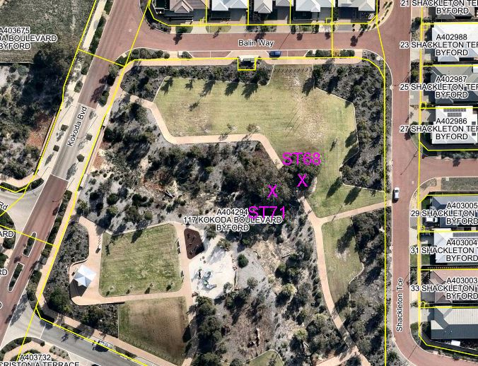

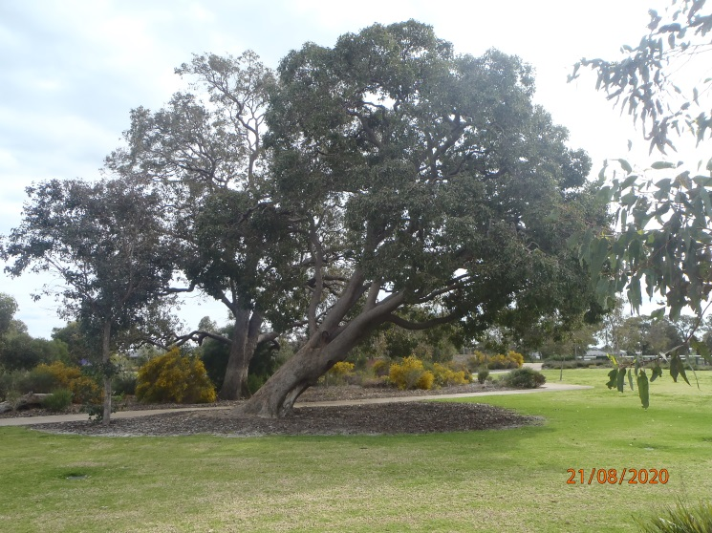
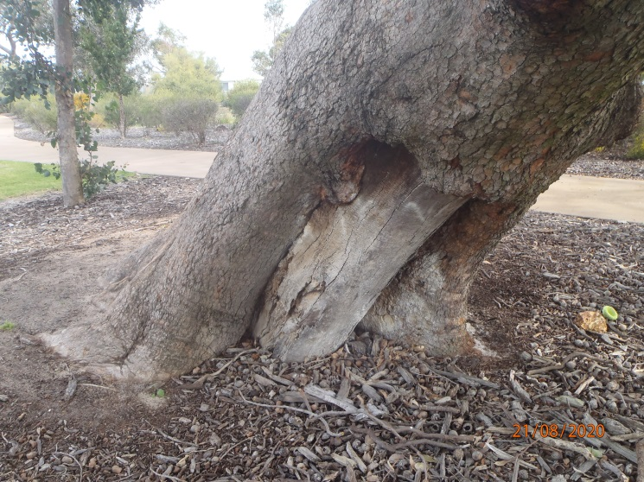
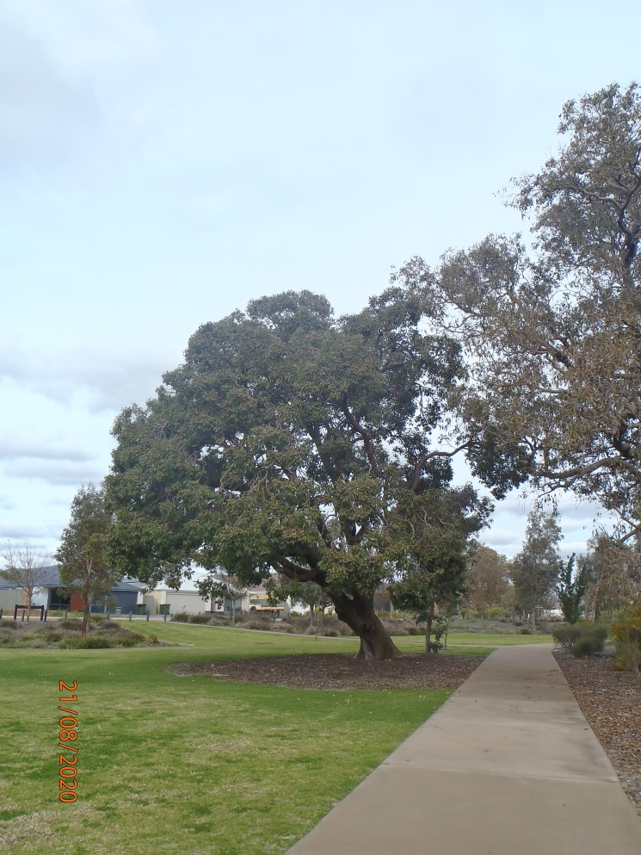

Significant Tree Register – Assessment Report – ST 71

Registry number: ST 71
Species: Corymbia calophylla (marri)
Number of trees: One

Height: 15 m
DBH: 96.5 cm
Canopy diameter: 16 m
Estimated age: 233 years (calculated)

Address: R52856, 117 (L8047) Kokoda Boulevard, Byford
Location description: South of the football posts, close to ST 68
GPS coordinates: 32.2299059 S, 115.9823604 E

Landowner: Crown land, Shire vesting
Category of significance: 2 (size), 3 (age)
Reasons for inclusion: Beautiful old native tree, provides shade, attracts black cockatoos, nice twisty branches
Risk assessment: Health poor, canopy declining, reasons unclear. Some old tear-outs.
Recommendation: Include on Register because:
- Beautiful old tree with habitat value
- Provides shade in park

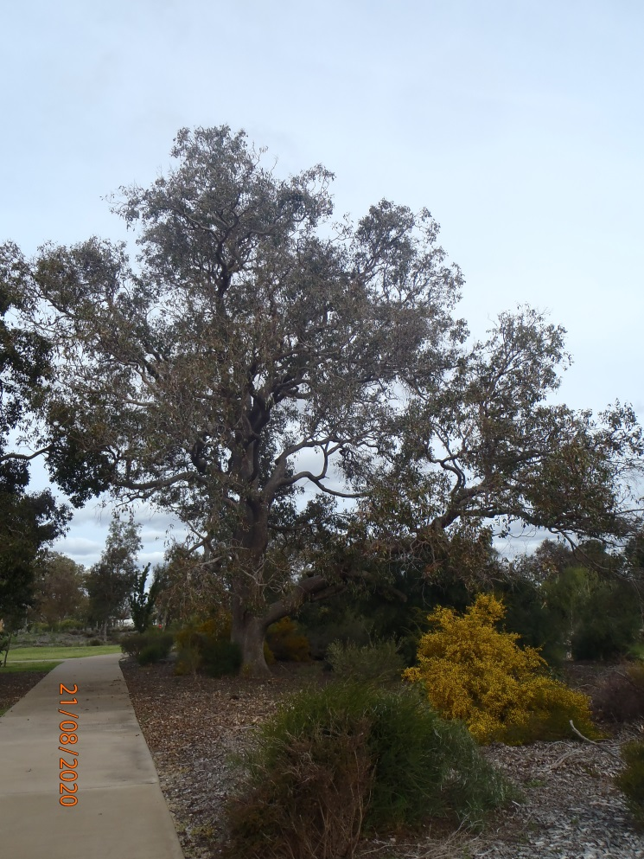

Significant Tree Register – Assessment Report – ST 72

Registry number: ST 72
Species: Eucalyptus wandoo (wandoo)
Number of trees: One

Height: 15 m
DBH (trunk diameter at 120cm): 51 cm, 49.5 cm, 39.5 cm, 30 cm, 19.5 cm (multistemmed)
Canopy diameter: 15 m
Estimated age: over 200 years

Address: R52753, L8001 Velvetene Road, Byford
Location description: Southwest corner of reserve on the corner of Abernethy Road and Gordin Way
GPS coordinates: 32.2231887 S, 116.0045235 E

Landowner: State of WA
Category of significance: 1 (aesthetics), 3 (age), 6 (location)
Reasons for inclusion: Beautiful mature, multistemmed wandoo, outside its normal environment (the westernmost wandoos in the Shire). Important central Byford site, highly visible near high school.
Risk assessment: Weed infestation and other degradation. Development of reserve.
Recommendation: Include on Register because:
- Beautiful mature, multistemmed wandoo
- Species is outside its normal environment (the westernmost wandoos in the Shire)
- Highly visible location

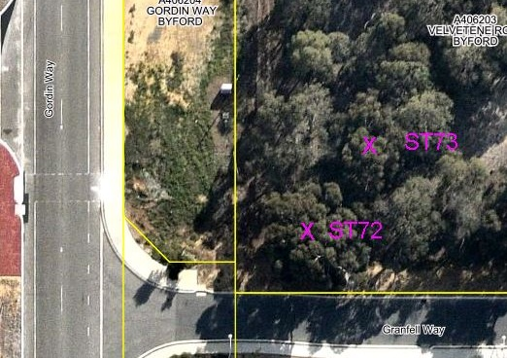

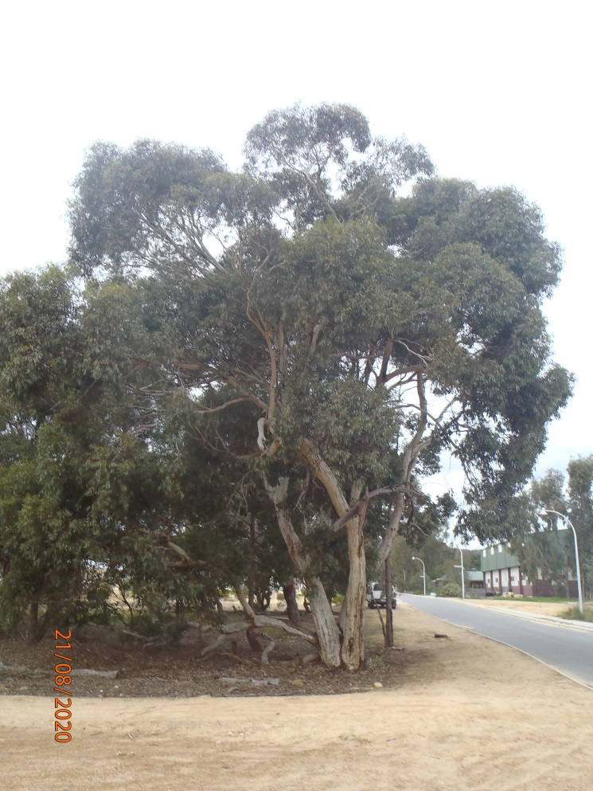

Significant Tree Register – Assessment Report – ST 73

Registry number: ST 73
Species: Eucalyptus wandoo (wandoo)
Number of trees: One

Height: 12 m
DBH (trunk diameter at 120cm): 39 cm, 34 cm, 17.5 cm (multistemmed)
Canopy diameter: 16 m
Estimated age: over 200 years

Address: R52753, L8001 Velvetene Road, Byford
Location description: Southwest corner of reserve on the corner of Abernethy Road and Gordin Way, northeast of ST 72
GPS coordinates: 32.2230899 S, 116.0045946 E

Landowner: State of WA
Category of significance: 1 (aesthetics), 3 (age), 6 (location)
Reasons for inclusion: Beautiful mature, multistemmed wandoo, outside its normal environment (the westernmost wandoos in the Shire). Important central Byford site, highly visible near high school.
Risk assessment: Weed infestation and other degradation. Development of reserve. Recommendation: Include on Register because:
- Beautiful mature, multistemmed wandoo
- Species is outside its normal environment (the westernmost wandoos in the Shire)
- Highly visible location

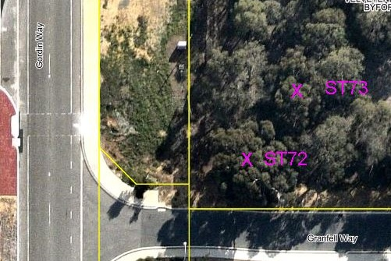

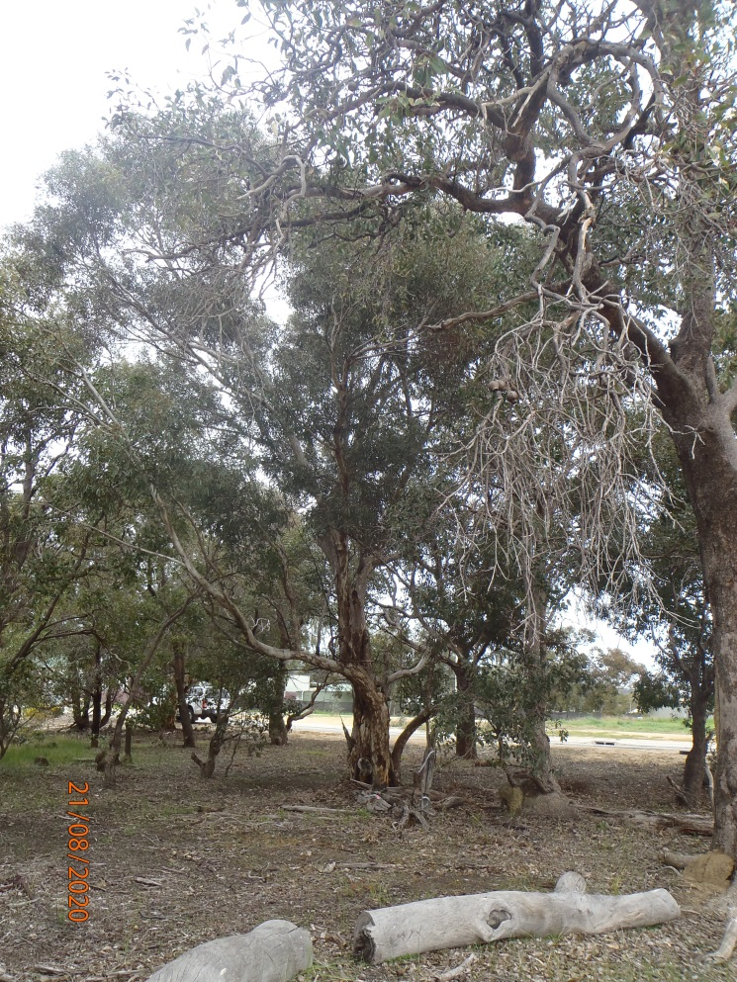

Significant Tree Register – Assessment Report – ST 74

Registry number: ST 74
Species: Eucalyptus wandoo (wandoo)
Number of trees: One

Height: 15 m
DBH (trunk diameter at 120cm): 75.5 cm, 16.5 cm
Canopy diameter: 16 m
Estimated age: over 200 years

Address: R52753, L8001 Velvetene Road, Byford
Location description: Southeast corner of reserve on the corner of Abernethy Road and Gordin Way
GPS coordinates: 32.2231671 S, 116.0048025 E

Landowner: State of WA
Category of significance: 1 (aesthetics), 3 (age), 6 (location)
Reasons for inclusion: Beautiful mature, multistemmed wandoo, outside its normal environment (the westernmost wandoos in the Shire). Important central Byford site, highly visible near high school.
Risk assessment: Weed infestation and other degradation. Development of reserve.
Recommendation: Include on Register because:
- Beautiful mature, multistemmed wandoo
- Species is outside its normal environment (the westernmost wandoos in the Shire)
- Highly visible location

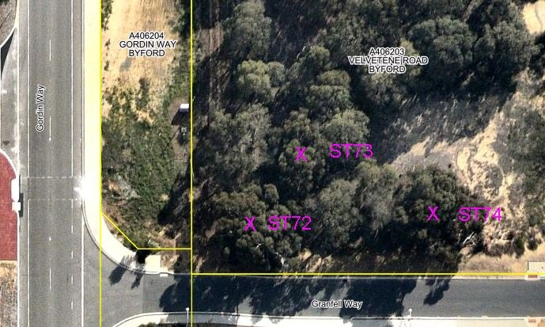

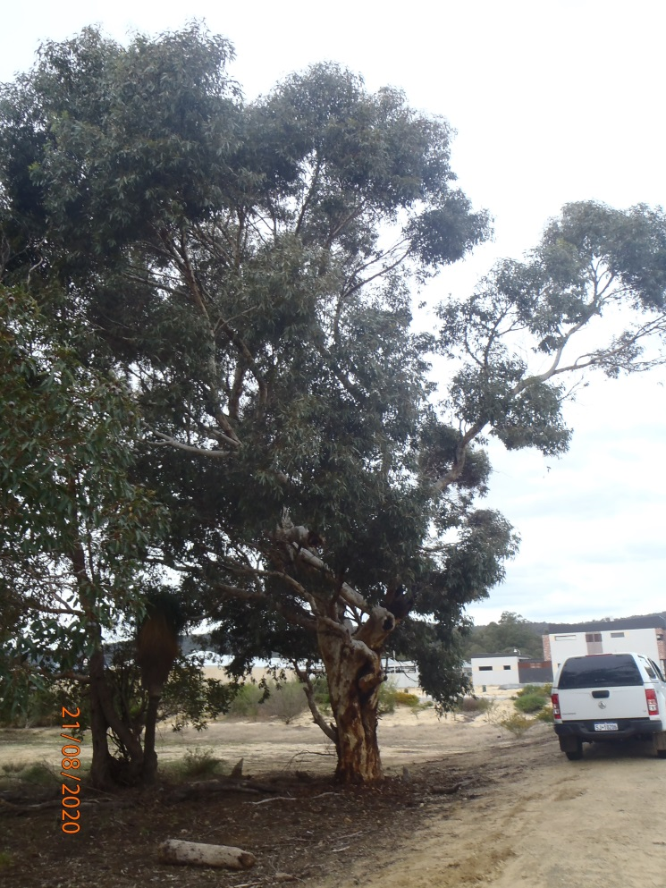

Significant Tree Register – Assessment Report – ST 75

Registry number: ST 75
Species: mostly Casuarina obesa (swamp sheoak) with a few Eucalyptus rudis (flooded gum)
Number of trees: approx. 470 (south of road – approx. 220 sheoaks and one flooded gum; north of road – approx. 250 sheoaks and one flooded gum)

Height: average 10 m
DBH (trunk diameter at 120cm): 5 cm to 30 cm, with some 60 cm to 100 cm
Canopy diameter: 1 m to 8 m
Estimated age: 2 years to 200 years

Address: Road reserve, Lowlands Road, Mardella
Location description: Tree tunnel on the road reserve, westernmost of two tunnels, shorter one
GPS coordinates: East 32.334394 S, 115.955559 E
West 32.334426 S, 115.953725 E

Landowner: Crown land, Shire vesting
Category of significance: 1 (aesthetics), 10 (avenue)
Reasons for inclusion: Beautiful tree tunnel over road, providing habitat for possums in trees, frogs in drains, contributing to ecological linkages. Highly valued by local community.
Risk assessment: Road widening or upgrades, pruning to protect trucks. Road is dead-end so traffic is local only.
Recommendation: Include on Register because:
- Beautiful tree tunnel over road
- Habitat for possums, frogs, ecological linkage
- Highly valued by local community

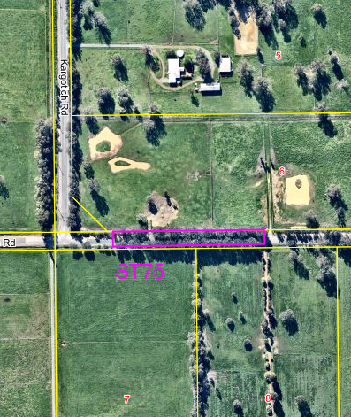
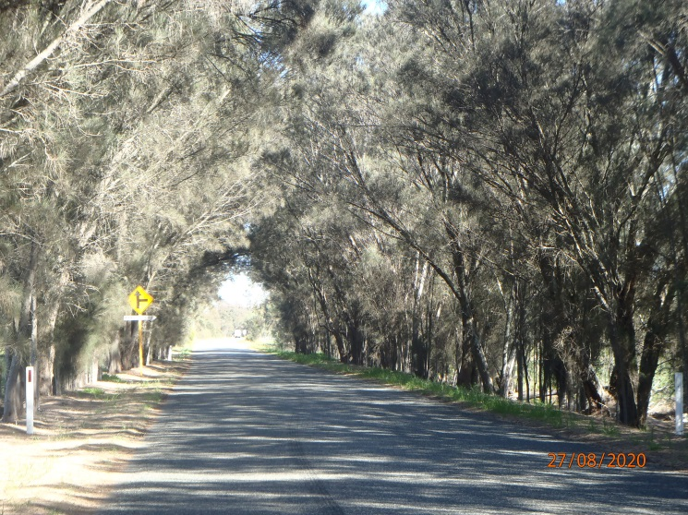
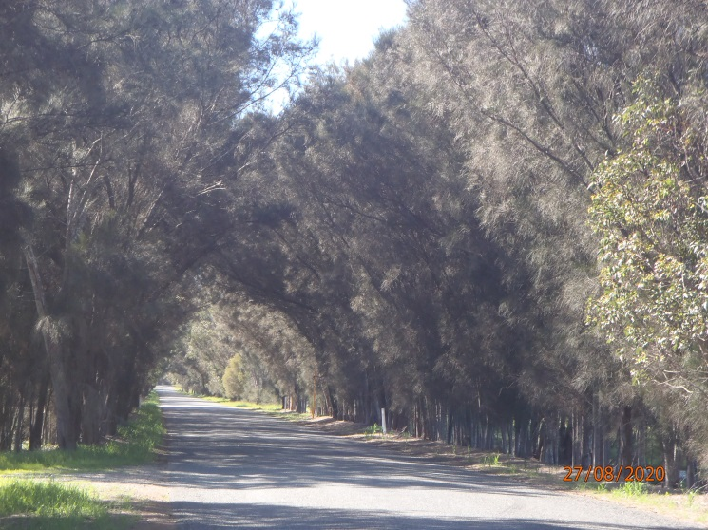

Significant Tree Register – Assessment Report – ST 76

Registry number: ST 76
Species: Casuarina obesa (swamp sheoak)
Number of trees: One

Height: 20 m
DBH (trunk diameter at 120cm): 115 cm
Canopy diameter: 15 m
Estimated age: 200 years

Address: Road reserve, Lowlands Road, Mardella
Location description: Within tree tunnel ST 27, on southern side of road
GPS coordinates: 32.334449 S, 115.959057 E

Landowner: Crown land, Shire vesting
Category of significance: 1 (aesthetics), 2 (size), 3 (age)
Reasons for inclusion: Unusually large and old tree with significant habitat value
Risk assessment: Road widening or upgrades, pruning to protect trucks. Road is dead-end so traffic is local only.
Recommendation: Include on Register because:
- Unusually large and old, attractive tree
- Significant habitat value

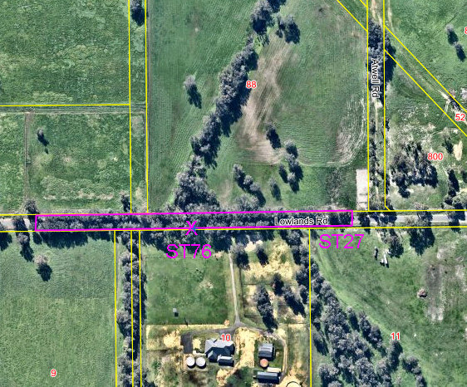

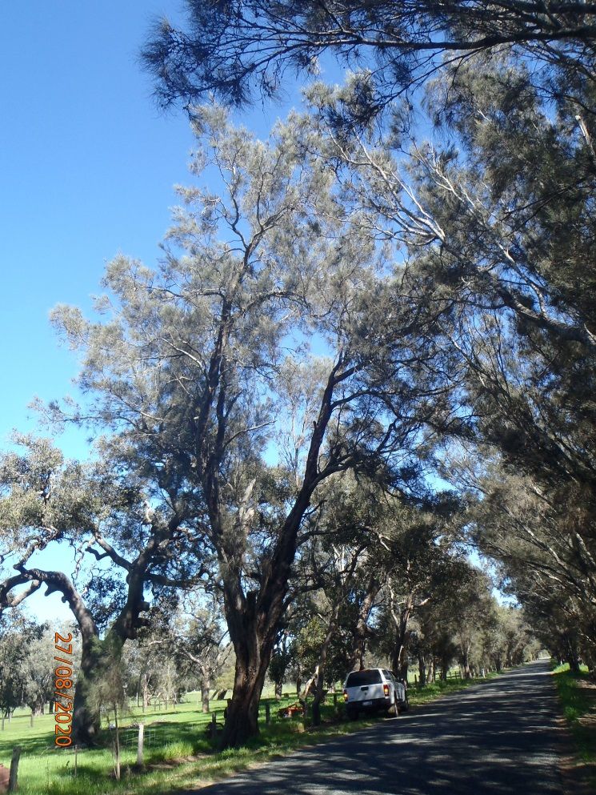

Significant Tree Register – Assessment Report – ST 77

Registry number: ST 77
Species: Corymbia calophylla (marri)
Number of trees: One

Height: 28 m
DBH (trunk diameter at 120cm): 122 cm
Canopy diameter: 23 m
Estimated age: 293 years (calculated)

Address: Road reserve, Lowlands Road, Mardella
Location description: Near entrance to Lowlands, northern side of the road, next to truck turnaround
GPS coordinates: 32.3317700 S, 115.9272270 E

Landowner: Crown land, Shire vesting
Category of significance: 1 (aesthetics), 2 (size), 3 (age)
Reasons for inclusion: A very large, old marri with significant habitat value
Risk assessment: Road widening or upgrades, pruning to protect trucks
Recommendation: Include on Register because:
- Very large, old marri with significant habitat value

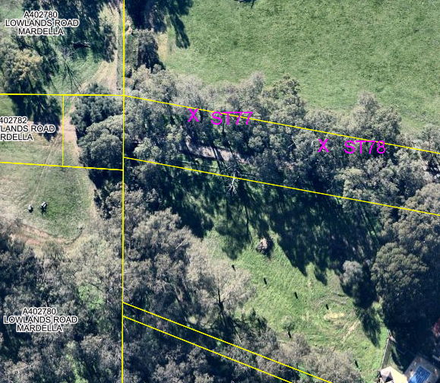
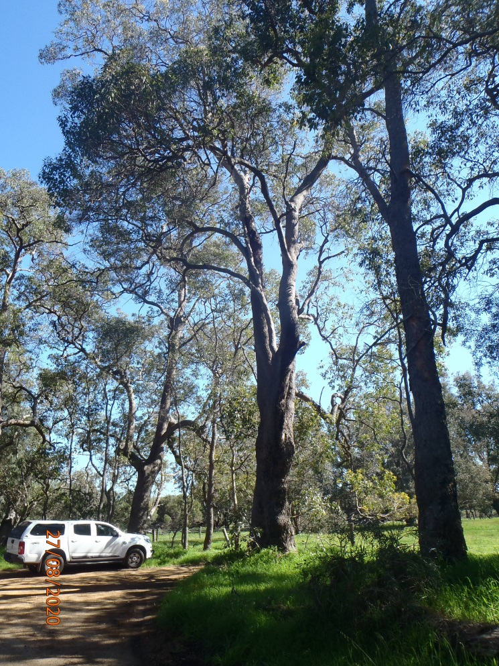

Significant Tree Register – Assessment Report – ST 78

Registry number: ST 78
Species: Corymbia calophylla (marri)
Number of trees: One

Height: 30 m
DBH (trunk diameter at 120cm): 164.5 cm
Canopy diameter: 30 m
Estimated age: 392 years (calculated)

Address: Road reserve, Lowlands Road, Mardella
Location description: Near entrance to Lowlands, northern side of the road, near (east of) ST 77
GPS coordinates: 32.3318482 S, 115.9275260 E

Landowner: Crown land, Shire vesting
Category of significance: 1 (aesthetics), 2 (size), 3 (age)
Reasons for inclusion: A very large and old marri with significant habitat value, very healthy and attractive, high buttress mound
Risk assessment: Road widening or upgrades, pruning to protect trucks
Recommendation: Include on Register because:
- Very large, old marri with significant habitat value
- Healthy and attractive with high buttress mound

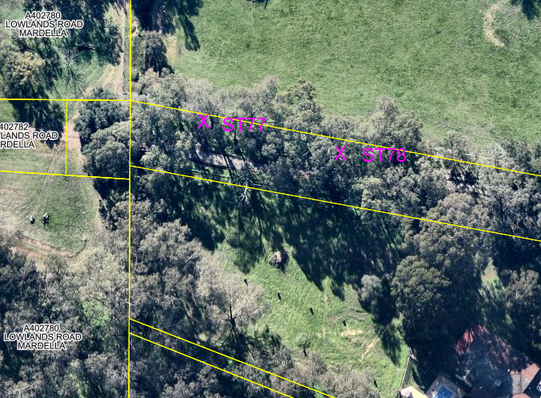
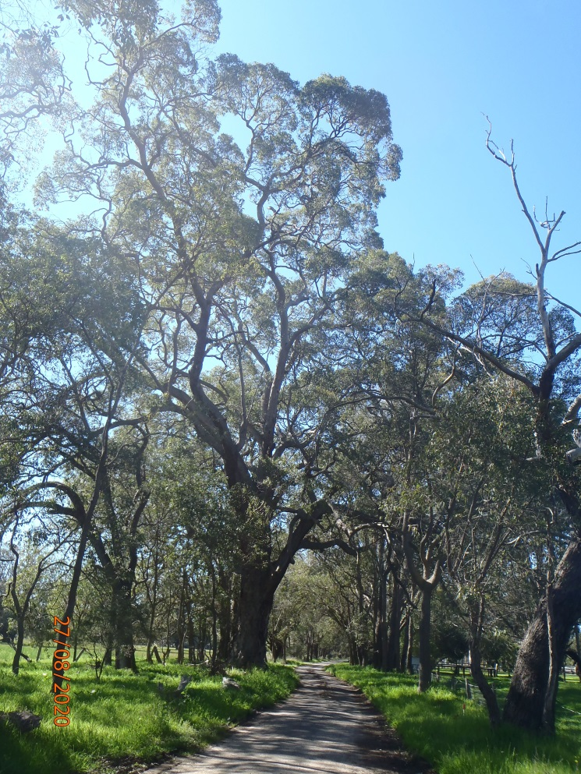

Significant Tree Register – Assessment Report – ST 79

Registry number: ST 79
Species: Corymbia calophylla (marri)
Number of trees: One

Height: 35 m
DBH (trunk diameter at 120cm): 140.5 cm
Canopy diameter: 24 m
Estimated age: 336 years (calculated)

Address: Road reserve, Lowlands Road, Mardella
Location description: Near entrance to Lowlands, southern side of road, east of ST 77 and ST 78, outside property #487
GPS coordinates: 32.3321337 S, 115.9290603 E

Landowner: Crown land, Shire vesting
Category of significance: 1 (aesthetics), 2 (size), 3 (age)
Reasons for inclusion: A very large and old marri with significant habitat value, obvious hollows forming
Risk assessment: Road widening or upgrades, pruning to protect trucks
Recommendation: Include on Register because:
- Very large, old marri with significant habitat value
- Obvious habitat hollows forming

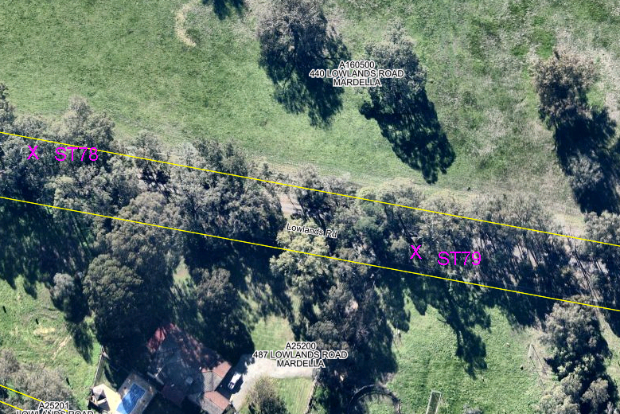
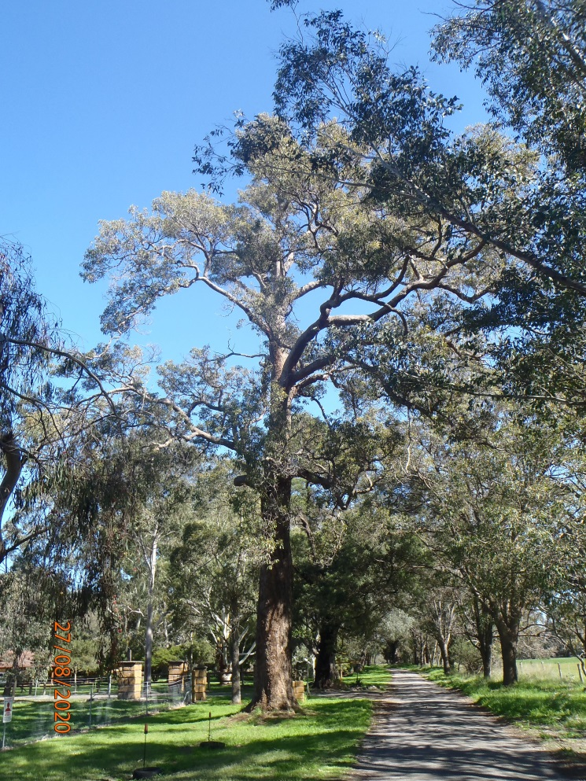

Significant Tree Register – Assessment Report – ST 85

Registry number: ST 85
Species: Corymbia calophylla (marri)
Number of trees: One

Height: 25 m
DBH (trunk diameter at 120cm): 152 cm
Canopy diameter: 22 m
Estimated age: 363 years (calculated)

Address: 172 (L113) Keirnan Street, Whitby
Location description: Behind (north of) the shed. Four other nominated trees on the property.
GPS coordinates: 32.2844015 S, 115.9982381 E

Landowner: Shire freehold
Category of significance: 1 (aesthetics), 2 (size), 3 (age)
Reasons for inclusion: Attractive, large old tree with high habitat value. Nice surroundings with grass trees and several smaller marris. Veldt grass does not grow under canopy (noticeable in all marris on property).
Risk assessment: Development of property, sale by Shire, subdivision.
Recommendation: Include on Register because:
- Attractive, large old tree with habitat value

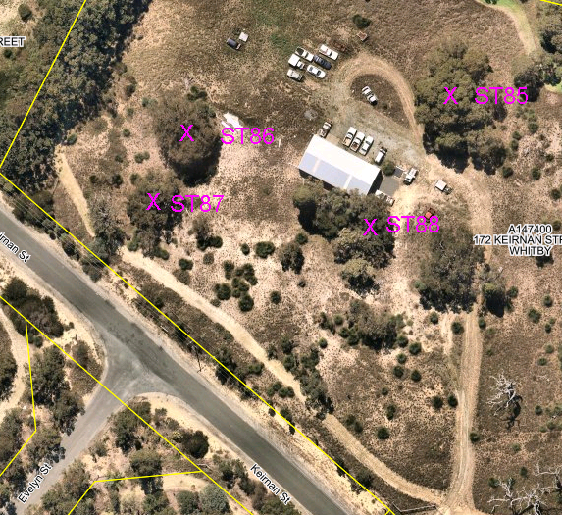

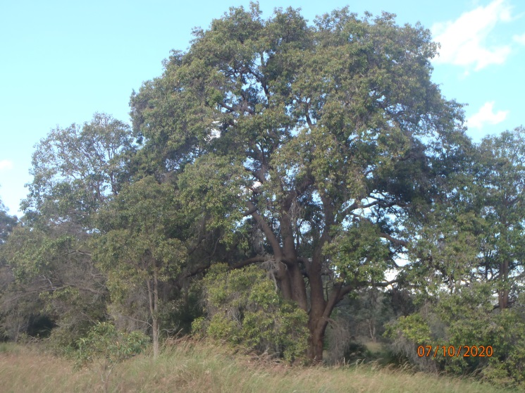

Significant Tree Register – Assessment Report – ST 87

Registry number: ST 87
Species: Eucalyptus marginata (jarrah)
Number of trees: One

Height: 20 m
DBH (trunk diameter at 120cm): 81.5 cm
Canopy diameter: 18 m
Estimated age: 200 years (calculated)

Address: 172 (L113) Keirnan Street, Whitby
Location description: Western side of property, south of ST 86. Four other nominated trees on the property.
GPS coordinates: 32.2846419 S, 115.9974160 E

Landowner: Shire freehold
Category of significance: 1 (aesthetics), 2 (size), 3 (age)
Reasons for inclusion: Attractive, large old tree with high habitat value.
Risk assessment: Development of property, sale by Shire, subdivision. Infestation of Acacia longifolia (Sydney golden wattle) under canopy.
Recommendation: Include on Register because:
- Attractive, large old tree with habitat value

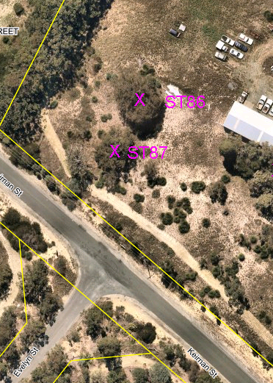
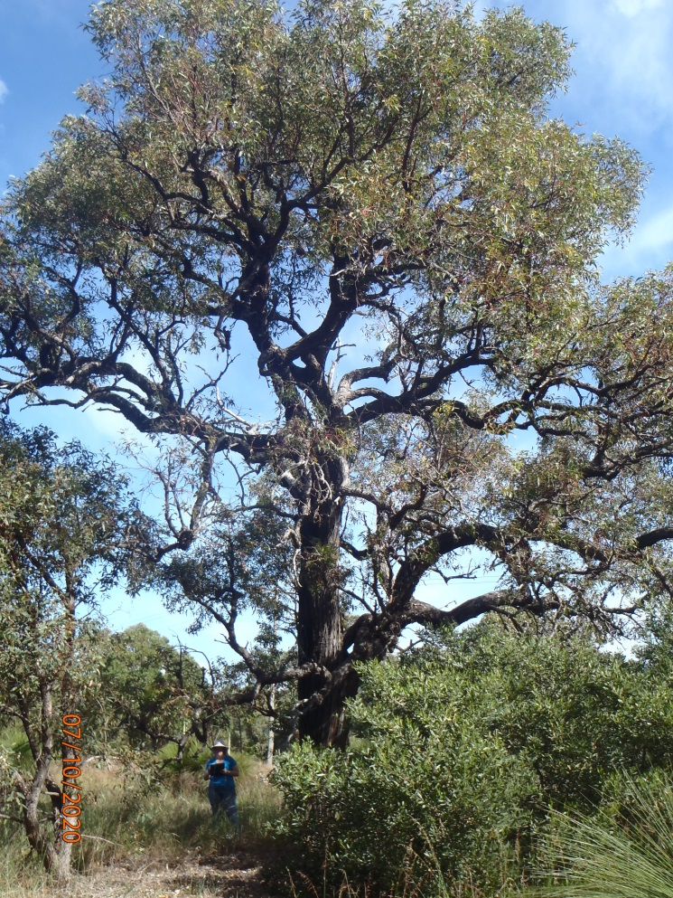

Significant Tree Register – Assessment Report – ST 88

Registry number: ST 88
Species: Eucalyptus marginata (jarrah)
Number of trees: Two

Height: 10m, 4m, 2m (multi-trunked),
8m, 6m, 4m, 3m (multi-trunked)
DBH (trunk diameter at 120cm): 103.5 cm, 25 cm, 15 cm (multi-trunked),
44 cm, 34 cm, 24 cm, 14.5 cm (multi-trunked)
Canopy diameter: 10 m, 4 m, 3m (multi-trunked),
9 m (total)
Estimated age: 249, 65, 42 years (calculated)
110, 86, 63, 40 years (calculated)

Address: 172 (L113) Keirnan Street, Whitby
Location description: Near the shed, on its eastern side. Four other nominated trees on the property.
GPS coordinates: 32.2846782 S, 115.9980074 E

Landowner: Shire freehold
Category of significance: 1 (aesthetics), 2 (size), 3 (age), 9 (unusual features), 10 (group)
Reasons for inclusion: Large and old with high habitat value, attractive multi-stemmed forms. Second tree is at least twice the calculated age, as it has a burnt out stump in the centre from which the other trunks sprouted.
Risk assessment: Development of property, sale by Shire, subdivision. First tree has numerous scars and several upper branches have been pruned, possibly after branch death.
Recommendation: Include on Register because:
- Large, old trees with high habitat value
- Attractive multi-stemmed forms

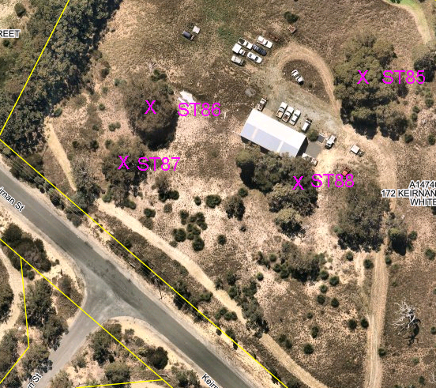
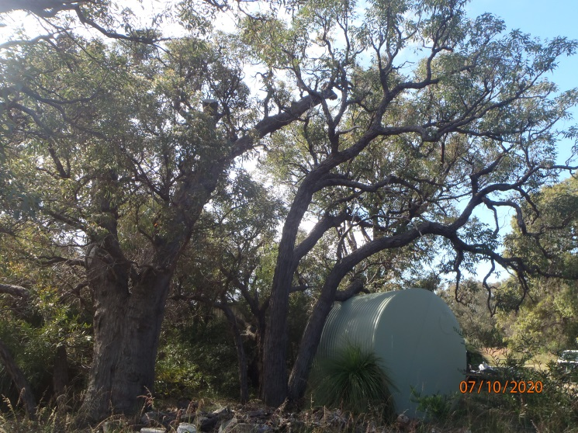

Significant Tree Register – Assessment Report – ST 91

Registry number: ST 91
Species: Eucalyptus marginata (jarrah)
Number of trees: One

Height: 25 m
DBH (trunk diameter at 120m): 126 cm, 41.5 cm (lying down), 26 cm (upright), 37 cm (dead) (multi-trunked)
Canopy diameter: 15 m
Estimated age: 302 years (calculated)

Address: Road reserve, Paterson Street, Mundijong
Location description: In front of old stockyards, across the road from the Landcare Centre
GPS coordinates: 32.2968003 S, 115.9853320 E

Landowner: Crown land, Shire vesting
Category of significance: 1 (aesthetics), 2 (size), 3 (age), 6 (location)
Reasons for inclusion: A beautiful old jarrah with high habitat value. Significant feature of Mundijong main street.
Risk assessment: Active termite run on north side, needs treatment. Badly affected by footpath installation, one dead trunk, branches over yards dying, staghorns. Cause of decline uncertain, could be root damage or possibly dieback (other nearby jarrahs also declining).
Recommendation: Include on Register because:
- Beautiful old jarrah with high habitat value
- Significant feature of Mundijong main street

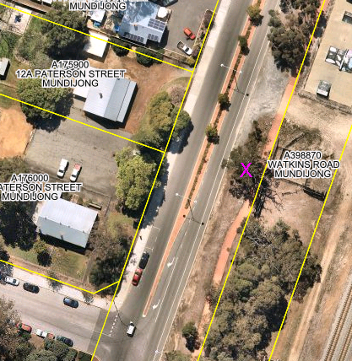
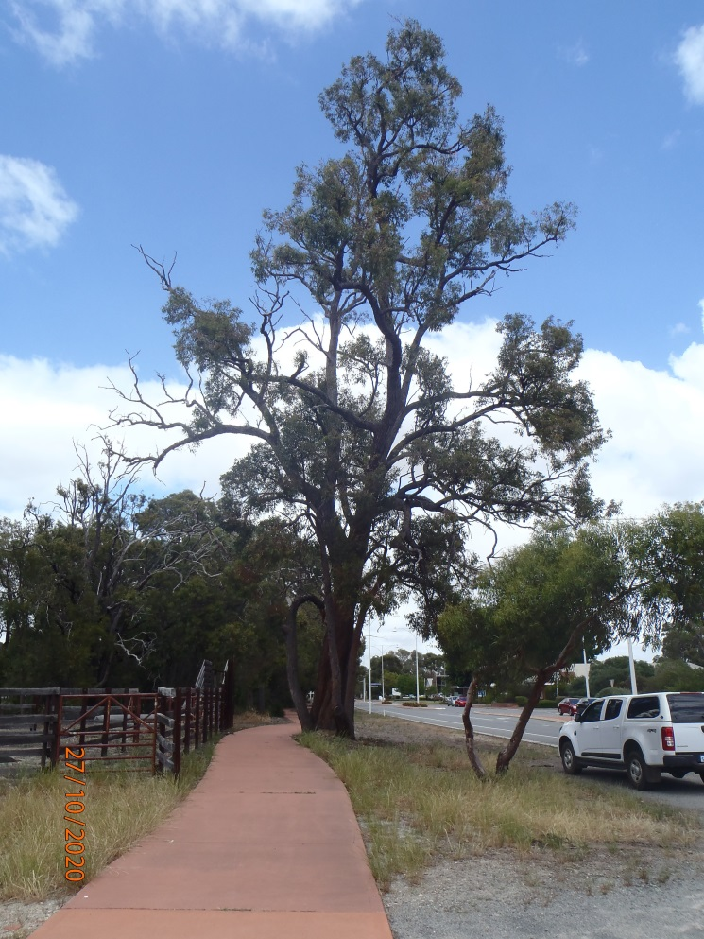

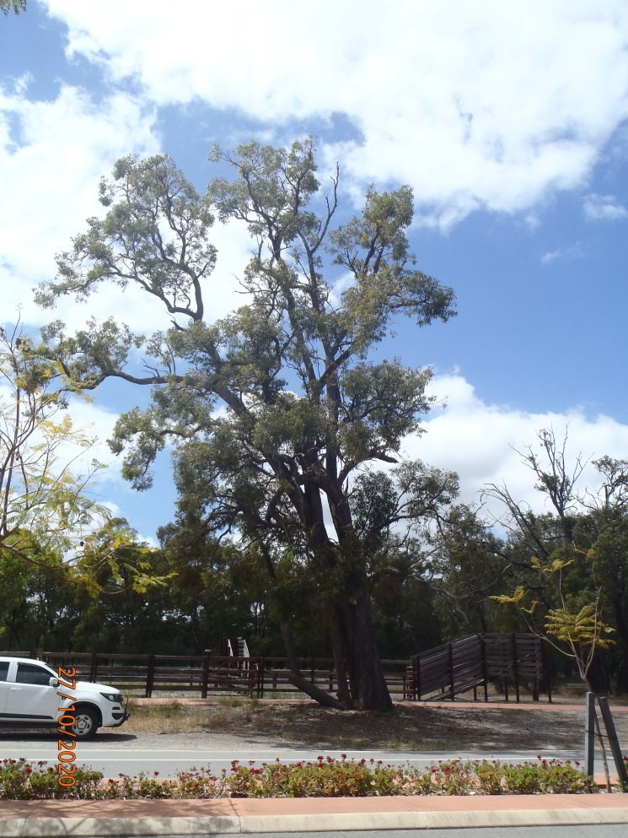

Significant Tree Register – Assessment Report – ST 92

Registry number: ST 92
Species: Corymbia citriodora (lemon scented gum)
Number of trees: One

Height: 30 m
DBH (trunk diameter at 120cm): 97 cm, 49.5 cm (double trunked)
Canopy diameter: 20 m
Estimated age: possibly over 100 years

Address: R32180, 12 (L218) Paterson Street, Mundijong
Location description: West of the Landcare Centre building
GPS coordinates: 32.2968371 S, 115.9845760 E

Landowner: Crown land, Shire vesting
Category of significance: 1 (aesthetics), 2 (size), 3 (age), 4 (historical)
Reasons for inclusion: Beautiful, large tree with lemon scent and white bark. Tree was planted many years ago, possibly during establishment or by students of Mundijong School (est. 1896). Significant feature in main street of Mundijong.
Risk assessment: Development of property, alternative use by Shire, sale or subdivision.
Recommendation: Include on Register because:
- Beautiful, big white-barked tree
- Historical planting, possibly by students of Mundijong School
- Significant feature in Mundijong main street

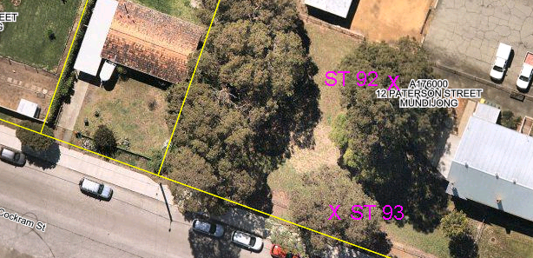

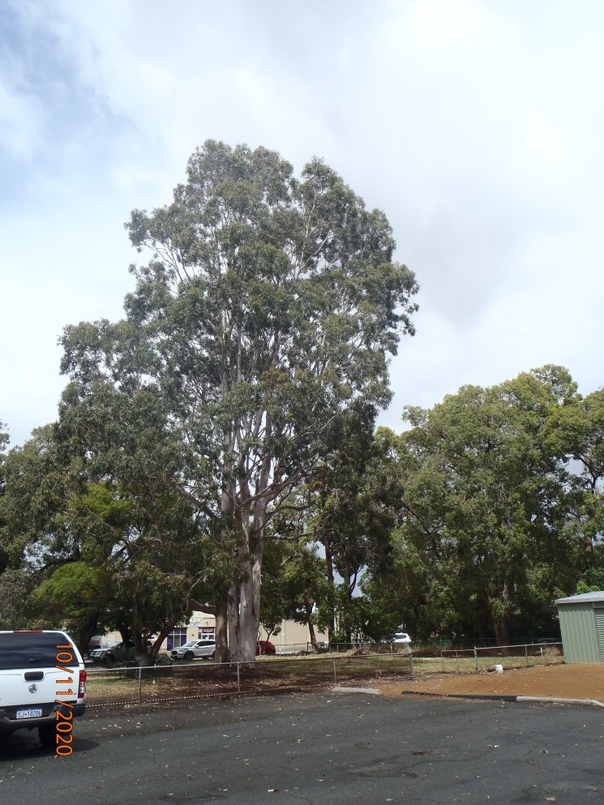

Significant Tree Register – Assessment Report – ST 93

Registry number: ST 93
Species: Corymbia calophylla (marri)
Number of trees: One

Height: 22 m
DBH (trunk diameter at 120 cm): 82.5 cm
Canopy diameter: 17 m
Estimated age: possibly over 100 years (calculated at 200 years)

Address: R32180, 12 (L218) Paterson Street, Mundijong
Location description: Midway along the southern boundary of the Landcare site
GPS coordinates: 32.2970015 S, 115.9844858 E

Landowner: Crown land, Shire vesting
Category of significance: 1 (aesthetics), 2 (size), 3 (age)
Reasons for inclusion: Large, old, beautiful tree with habitat value. Probably self-seeded on the old Mundijong School site prior to establishment. Significant feature of Mundijong main street.
Risk assessment: Development of property, alternative use by Shire, sale or subdivision.
Recommendation: Include on Register because:
- Beautiful, big marri with habitat value
- Significant feature in Mundijong main street

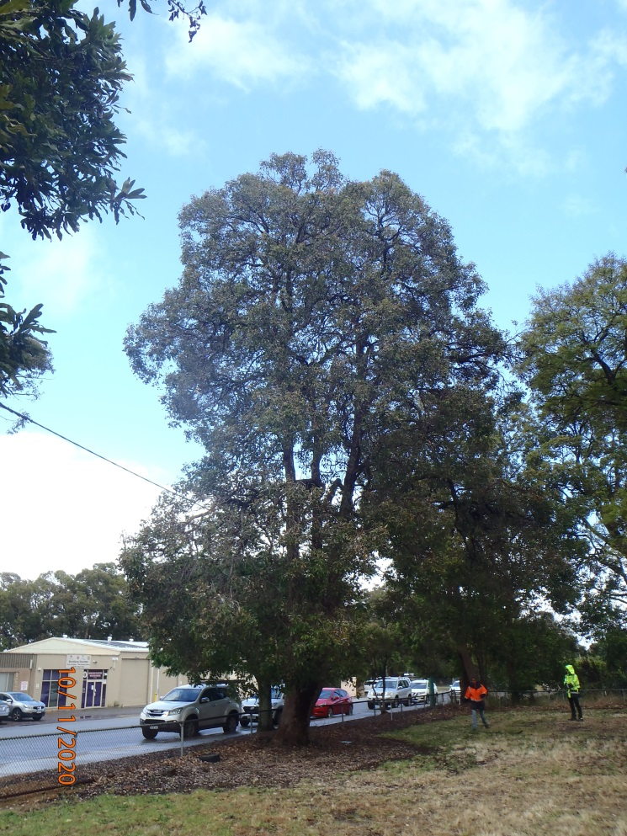

Significant Tree Register – Assessment Report – ST 94

Registry number: ST 94
Species: Cinnamomum camphora (camphor laurel)
Number of trees: One

Height: 20 m
DBH (trunk diameter at 120cm): 111 cm
Canopy diameter: 17 m
Estimated age: possibly over 100 years

Address: R32180, 12 (L218) Paterson Street, Mundijong
Location description: Eastern boundary (Paterson Street frontage), just north of the gate
GPS coordinates: 32.2968371 S, 115.9849900 E

Landowner: Crown land, Shire vesting
Category of significance: 1 (aesthetics), 2 (size), 3 (age), 4 (historical)
Reasons for inclusion: Beautiful, large tree often planted by early settlers. Tree was planted many years ago, possibly during establishment or by students of Mundijong School (est. 1896). Significant feature in main street of Mundijong.
Risk assessment: Development of property, alternative use by Shire, sale or subdivision.
Recommendation: Include on Register because:
- Beautiful, big tree
- Historical planting, possibly by students of Mundijong School
- Significant feature in Mundijong main street

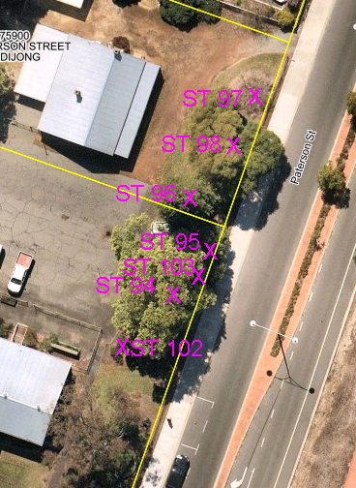

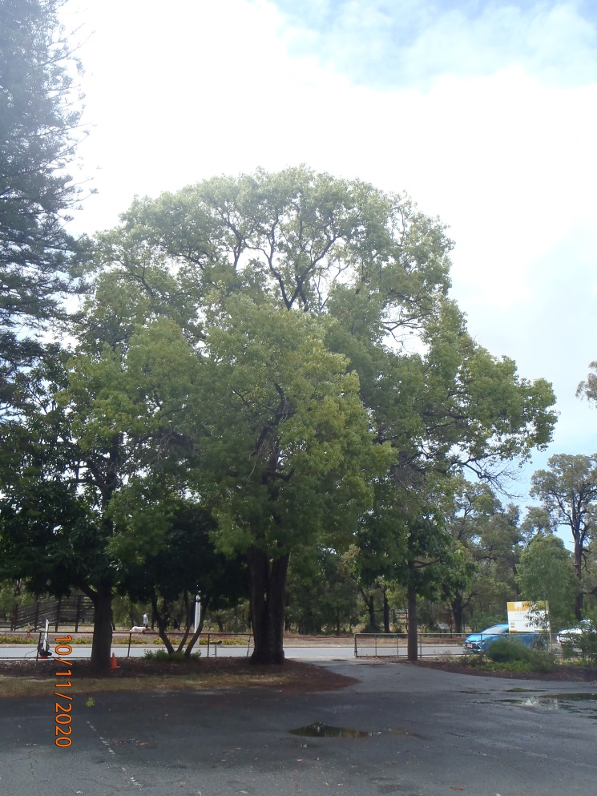

Significant Tree Register – Assessment Report – ST 95

Registry number: ST 95
Species: Brachychiton acerifolius (Illawarra flame tree)
Number of trees: One

Height: 18 m
DBH (trunk diameter at 120cm): 69 cm
Canopy diameter: 8 m
Estimated age: possibly over 100 years

Address: R32180, 12 (L218) Paterson Street, Mundijong
Location description: Eastern boundary of lot (Paterson Street frontage), north of ST 94
GPS coordinates: 32.2967793 S, 115.9850463 E

Landowner: Crown land, Shire vesting
Category of significance: 1 (aesthetics), 3 (age), 4 (historical), 8 (horticultural value)
Reasons for inclusion: Spectacular red flowers. Tree was planted many years ago, possibly during establishment or by students of Mundijong School (est. 1896). Significant feature in main street of Mundijong. Uncommon in WA.
Risk assessment: Development of property, alternative use by Shire, sale or subdivision.
Recommendation: Include on Register because:
- Beautiful tree with spectacular red flowers
- Historical planting, possibly by students of Mundijong School
- Significant feature in Mundijong main street
- Uncommon in WA

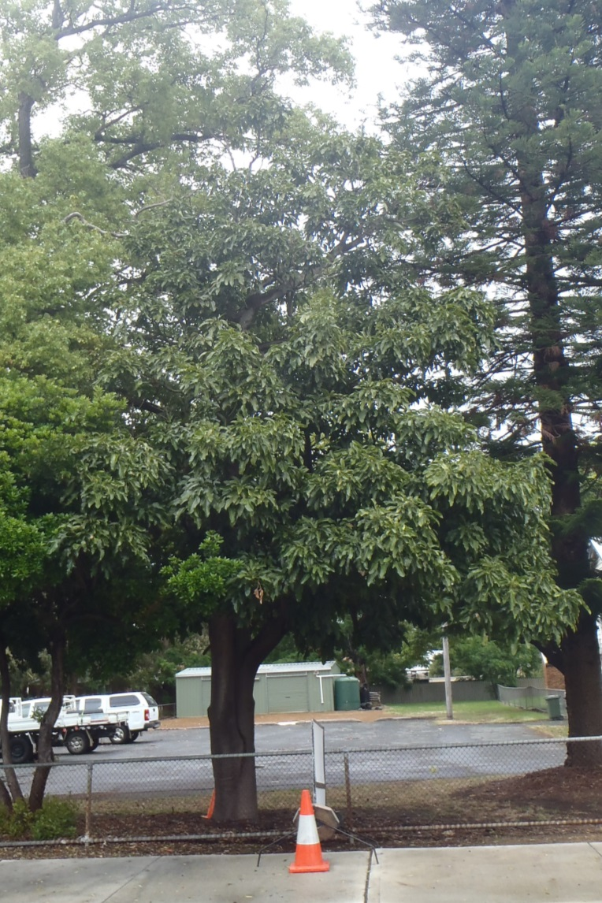

Significant Tree Register – Assessment Report – ST 96

Registry number: ST 96
Species: Araucaria heterophylla (Norfolk Island pine)
Number of trees: One

Height: 35 m
DBH (trunk diameter at 120cm): 99 cm
Canopy diameter: 9 m
Estimated age: possibly over 100 years

Address: R32180, 12 (L218) Paterson Street, Mundijong
Location description: Eastern boundary of lot (Paterson Street frontage), north of ST 95.
GPS coordinates: 32.2967271 S, 115.9850168 E

Landowner: Crown land, Shire vesting
Category of significance: 1 (aesthetics), 2 (size), 3 (age), 4 (historical)
Reasons for inclusion: Beautiful, large tree planted many years ago, possibly during establishment or by students of Mundijong School (est. 1896). Significant feature in main street of Mundijong.
Risk assessment: Development of property, alternative use by Shire, sale or subdivision.
Recommendation: Include on Register because:
- Beautiful, big tree
- Historical planting, possibly by students of Mundijong School
- Significant feature in Mundijong main street

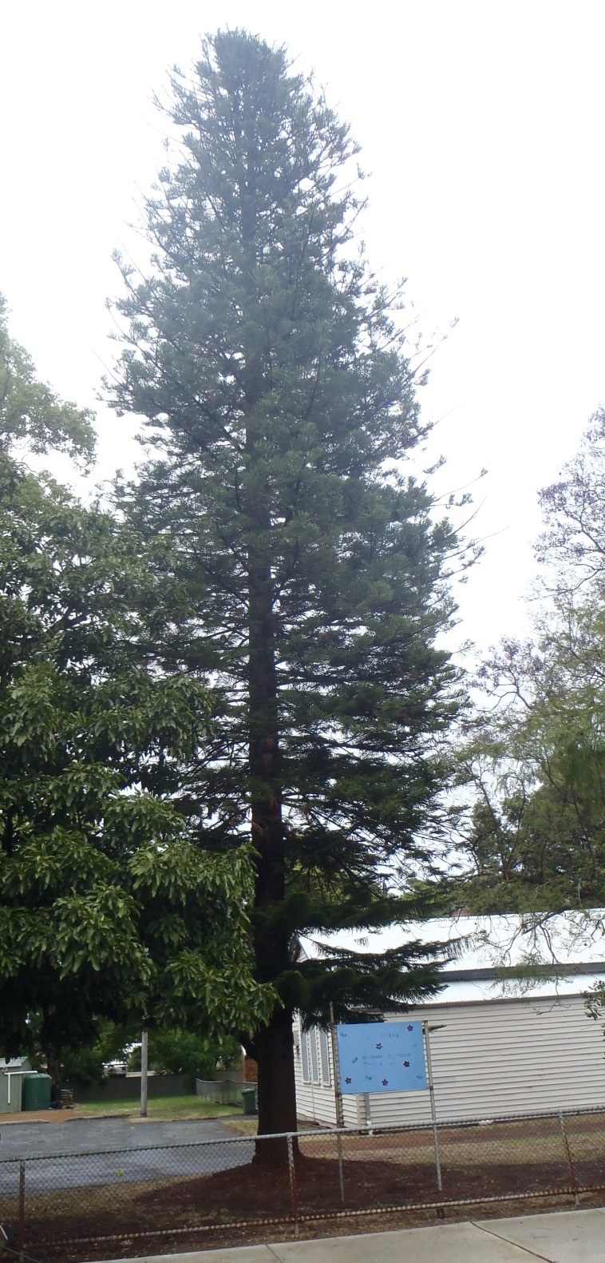

Significant Tree Register – Assessment Report – ST 98

Registry number: ST 98
Species: Jacaranda mimosifolia (jacaranda)
Number of trees: One

Height: 20 m
DBH (trunk diameter at 120cm): 52.5 cm, 28.5 cm, 28.5 cm, 13 cm, 13 cm, 11 cm, 14 cm (multi-trunked)
Canopy diameter: 15 m
Estimated age: possibly over 100 years

Address: R32180, 12a (L219) Paterson Street, Mundijong
Location description: Eastern boundary of lot (Paterson Street frontage), between ST 96 and ST 97
GPS coordinates: 32.2966671 S, 115.9850919 E

Landowner: Crown land, Shire vesting
Category of significance: 1 (aesthetics), 2 (size), 3 (age), 4 (historical)
Reasons for inclusion: Beautiful, large tree with attractive purple flowers, planted many years ago, possibly during establishment or by students of Mundijong School (est. 1896). Significant feature in main street of Mundijong.
Risk assessment: Development of property, alternative use by Shire, sale or subdivision.
Recommendation: Include on Register because:
- Beautiful, big tree with purple flowers
- Historical planting, possibly by students of Mundijong School
- Significant feature in Mundijong main street

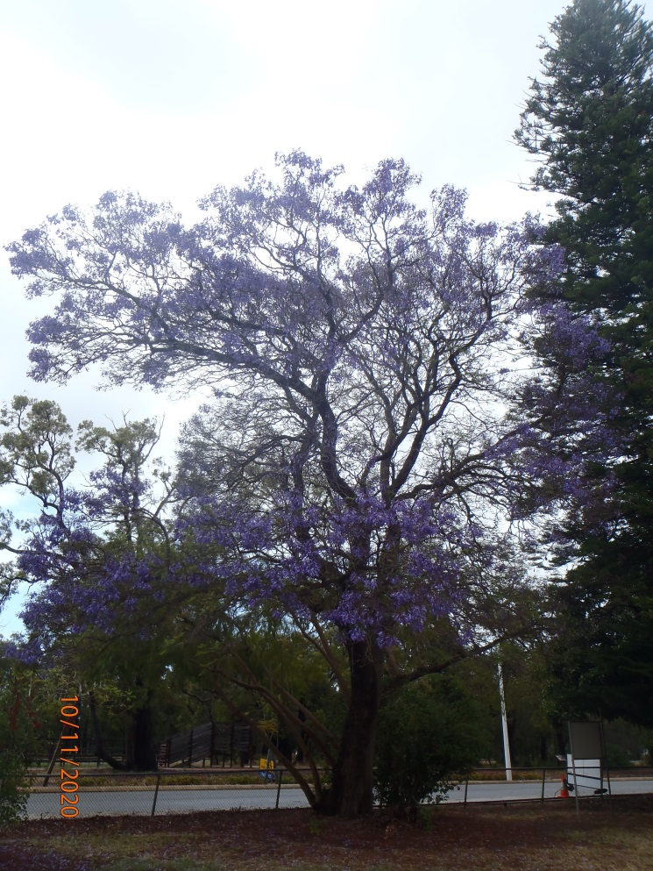

Significant Tree Register – Assessment Report – ST 99

Registry number: ST 99
Species: Cinnamomum camphora (camphor laurel)
Number of trees: One

Height: 15 m
DBH (trunk diameter at 120cm): 118 cm
Canopy diameter: 17 m
Estimated age: possibly over 100 years

Address: R32180, 12a (L219) Paterson Street, Mundijong
Location description: West of the playgroup building, just north of the fence from Landcare
GPS coordinates: 32.2965900 S, 115.9846842 E

Landowner: Crown land, Shire vesting
Category of significance: 1 (aesthetics), 2 (size), 3 (age), 4 (historical)
Reasons for inclusion: Beautiful, large tree often planted by early settlers. Tree was planted many years ago, possibly during establishment or by students of Mundijong School (est. 1896). Significant feature in main street of Mundijong.
Risk assessment: Development of property, alternative use by Shire, sale or subdivision.
Recommendation: Include on Register because:
- Beautiful, big tree
- Historical planting, possibly by students of Mundijong School
- Significant feature in Mundijong main street

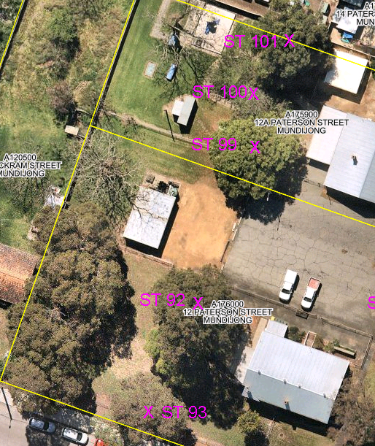

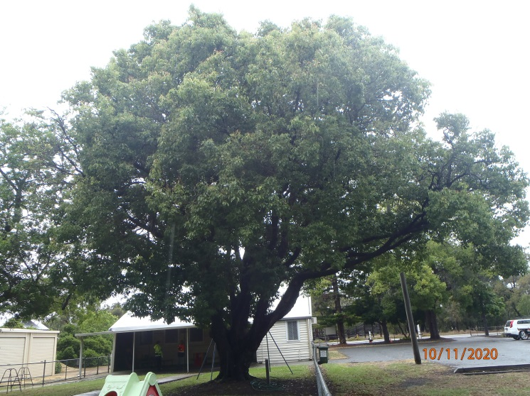

Significant Tree Register – Assessment Report – ST 100

Registry number: ST 100
Species: Schinus terebinthifolia (Brazilian pepper tree)
Number of trees: One

Height: 10 m
DBH (trunk diameter at 120cm): 60 cm, 52 cm, 51.5 cm, 26 cm (multi-trunked)
Canopy diameter: 17 m
Estimated age: possibly over 100 years

Address: R32180, 12a (L219) Paterson Street, Mundijong
Location description: West of the playgroup building, north of ST 99
GPS coordinates: 32.2965129 S, 115.9847057 E

Landowner: Crown land, Shire vesting
Category of significance: 1 (aesthetics), 2 (size), 3 (age), 4 (historical)
Reasons for inclusion: Tree was planted many years ago, possibly during establishment or by students of Mundijong School (est. 1896). Significant feature in main street of Mundijong.
Risk assessment: Development of property, alternative use by Shire, sale or subdivision.
Recommendation: Include on Register because:
- Historical planting, possibly by students of Mundijong School
- Significant feature in Mundijong main street

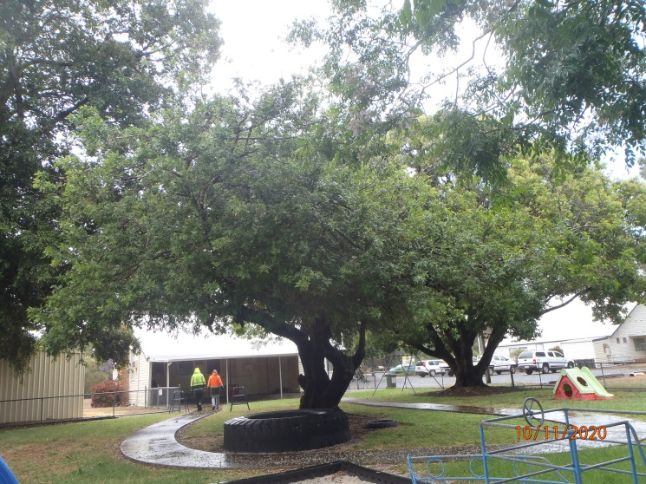

Significant Tree Register – Assessment Report – ST 101

Registry number: ST 101
Species: Acmena smithii (lilly pilly)
Number of trees: One

Height: 25 m
DBH (trunk diameter at 120cm): 75.5 cm
Canopy diameter: 13 m
Estimated age: possibly over 100 years

Address: R32180, 12a (L219) Paterson Street, Mundijong
Location description: West of the playgroup building, north of ST 100, near the northern boundary of the lot
GPS coordinates: 32.2964165 S, 115.9847459 E

Landowner: Crown land, Shire vesting
Category of significance: 1 (aesthetics), 2 (size), 3 (age), 4 (historical)
Reasons for inclusion: Beautiful, large tree planted many years ago, possibly during establishment or by students of Mundijong School (est. 1896). Significant feature in main street of Mundijong. Uncommon in WA.
Risk assessment: Development of property, alternative use by Shire, sale or subdivision.
Recommendation: Include on Register because:
- Beautiful, big tree
- Historical planting, possibly by students of Mundijong School
- Significant feature in Mundijong main street
- Uncommon in WA

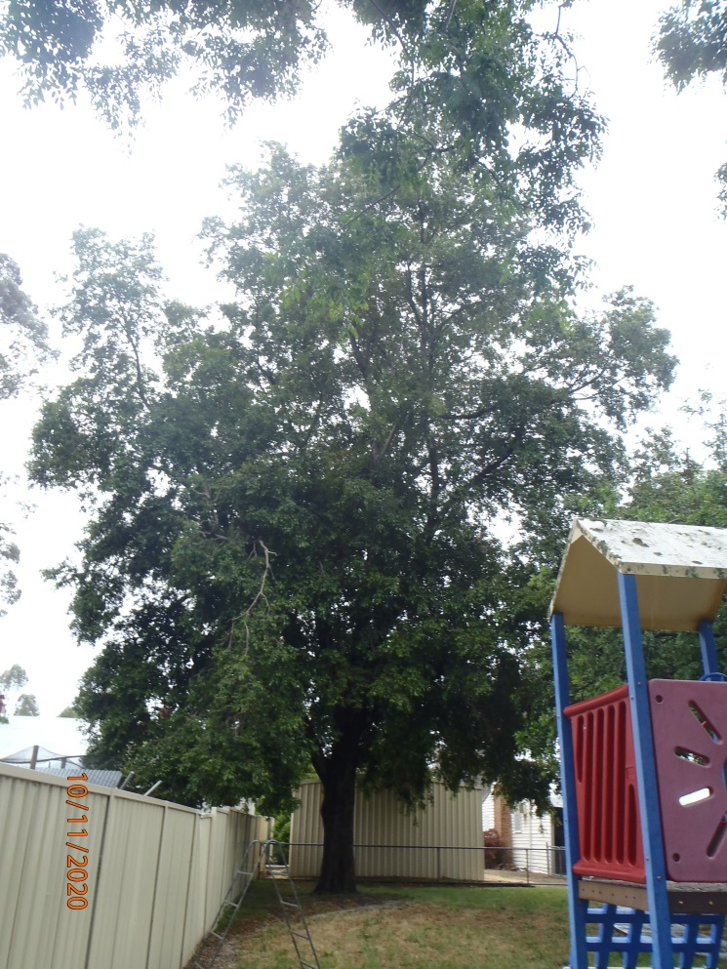

Significant Tree Register – Assessment Report – ST 102

Registry number: ST 102
Species: Brachychiton acerifolius (Illawarra flame tree)
Number of trees: One

Height: 8 m
DBH (trunk diameter at 120cm):
Canopy diameter: 4 m
Estimated age: possibly over 100 years

Address: R32180, 12 (L218) Paterson Street, Mundijong
Location description: Eastern boundary of lot (Paterson Street frontage), south of the entry gate
GPS coordinates: 32.2968986 S, 115.9849332 E

Landowner: Crown land, Shire vesting
Category of significance: 1 (aesthetics), 2 (size), 3 (age), 4 (historical), 8 (horticultural value)
Reasons for inclusion: Spectacular red flowers. Tree was planted many years ago, possibly during establishment or by students of Mundijong School (est. 1896). Significant feature in main street of Mundijong. Uncommon in WA.
Risk assessment: Development of property, alternative use by Shire, sale or subdivision.
Recommendation: Include on Register because:
- Beautiful tree with spectacular red flowers
- Historical planting, possibly by students of Mundijong School
- Significant feature in Mundijong main street
- Uncommon in WA

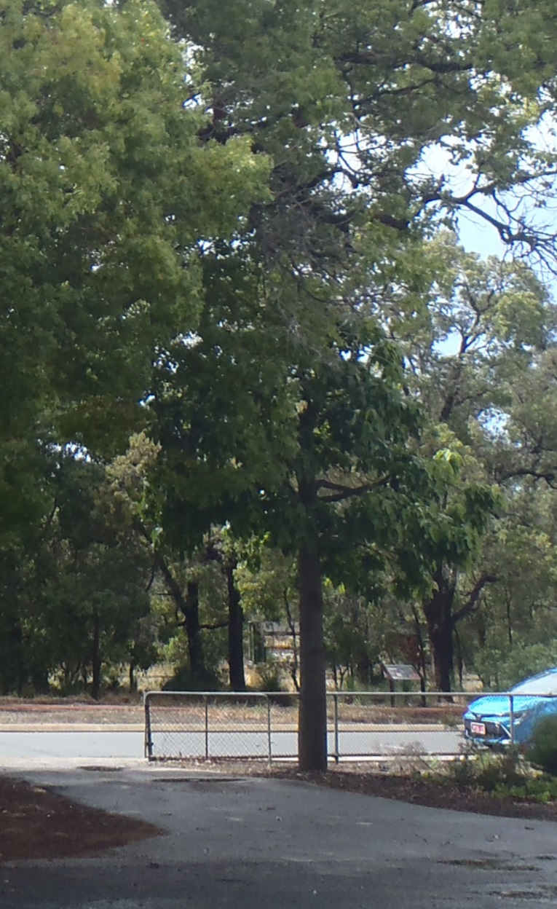

Significant Tree Register – Assessment Report – ST 103

Registry number: ST 103
Species: Arbutus unedo (Irish strawberry tree)
Number of trees: One

Height: 6 m
DBH (trunk diameter at 120cm):
Canopy diameter: 6 m
Estimated age: possibly over 100 years

Address: R32180, 12 (L218) Paterson Street, Mundijong
Location description: Eastern boundary of lot (Paterson Street frontage), under and north of ST 94
GPS coordinates: 32.2968149 S, 115.9850376 E

Landowner: Crown land, Shire vesting
Category of significance: 1 (aesthetics), 3 (age), 4 (historical), 8 (horticultural value)
Reasons for inclusion: : Unusual plant with edible strawberry-like fruit. Tree was planted many years ago, possibly during establishment or by students of Mundijong School (est. 1896). Significant feature in main street of Mundijong. Uncommon in WA.
Risk assessment: Development of property, alternative use by Shire, sale or subdivision.
Recommendation: Include on Register because:
- Unusual plant with edible strawberry-like fruit
- Historical planting, possibly by students of Mundijong School
- Significant feature in Mundijong main street
- Uncommon in WA

